**PROJECT REPORT**

**"Study2Success** " is a EdTech Application which provides online learning facilities for students who buy that course

**Submitted to: -**

**Modern Institute of Technology, Rishikesh**

IN PARTIAL FULFILMENT OF THE REQUIREMENTS FOR QUALIFYING,

**BACHELOR OF COMPUTER APPLICATION**

**(2022-2025)**

**Department of Computer Science and Information Technology**

Submitted by: -

**LAKSHYA**

Under the supervision of

**Mrs. Manorama Uniyal**

**Asst. Professor of**

**Computer Science and Information Technology Department**

**MODERN INSTITUTE OF TECHNOLOGY**

**DHALWALA, RISHIKESH (UTTARAKHAND)**

*AFFILIATED TO*

H.N.B. GARHWAL UNIVERSITY



**Enrollment No: G222290035**

**Roll No: 22229512034**





**MODERN INSTITUTE OF TECHNOLOGY**

**(Affiliated to H.N.B. Garhwal University, Srinagar (Garhwal) UGC Ranked NAAC accredited, approved by AICTE, NCTE, PCI, UTU, Uttarakhand Board of Technical Education & Govt. of Uttarakhand)**

DHALWALA, RISHIKESH – 249 201, UTTARAKHAND

**CERTIFICATE OF PROJECT**

**To Whom So Ever It May Concern**

This is certified that **Lakshya** is student of **BCA 6th Semester**. He has Completed his Major Project Work **Study2Success** under the curriculum of **HNB GARHWAL UNIVERSITY SRINAGAR.**

This Project work is his original work under guidance of **Mrs. Manorama Uniyal, Asst. Professor** Department of Computer Science and Information Technology of **MIT Dhalwala, Rishikesh.**

I Wish all the best of his future.

**Signature of Guide**

**DECLARATION**

  I hereby declare that the work which is being presented in the Project report entitled, "**Study2Success**", submitted by me in partial fulfillment of the requirements for the award of degree of Bachelor in Computer Science and Information Technology of Modern Institute of Technology, Rishikesh, is an authentic record of my own work carried out under the supervision of **Mrs. MANORAMA UNIYAL** and refers other developer works which are duly listed in the reference section.

The matter presented in this Project Report has not been submitted for the award of any other degree of this or any other university.

**(LAKSHYA)**

**ACKNOWLEDGEMENT**

Our project title, "**Study2Success**" requires a lot of hard work, sincerity and systematic work methodologies.

We express our deepest gratitude to my project guide **Mrs. Manorama Uniyal ma'am**, for giving me an opportunity to be a part of this exciting project and guiding me at every step of the project.

We would like to thank **Dr. Pradeep Pokhriyal**, **Head of Department of CS &IT** and **all BCA faculty members** who regularly evaluated our project and pointed out the shortcoming in the project. They gave us important suggestions for the future improvement of our project. I highly indebted to them.

**AYUSH KUKRETI**

**CONTENT**

|  |  |  |  |
| --- | --- | --- | --- |
| **S. NO** | **TITLE** | **PAGE NO** | **TEACHER’s SIGN** |
| **1** | **ABSTRACT** | 08 |  |
| **2** | **INTRODUCTION**  1.1 Title  1.2 Introduction  1.3 Objectives | 09-10 |  |
| **3** | **PRELIMINARY SYSTEM ANALYSIS**  2.1 Feasibility Study | 11-12 |  |
| **4** | **PROJECT CATEGORY SOFTWARE / HARDWARE REQUIREMENTS**  3.1 Technologies Used  3.2 About Languages  3.3 Tools | 13-15 |  |
| **5** | **SYSTEM DESIGN SPECIFICATION**  4.1 Problem Definition  4.2 Proposed System Requirement Analysis  4.3 ER Diagram for Table Relationship  4.4 Flow Chart for Login  4.5 Flow Chart for Signup  4.6 Flow Chart for Forgot Password  4.7 Flow Chart for Upload or Change Photo  4.8 Flow Chart for Change Personal Details  4.9 Flow Chart for Change Password  4.10 Flow Chart for Logout  4.11 Flow Chart for Show Categories (Only Admin)  4.12 Flow Chart for Add Categories (Only Admin)  4.13 Flow Chart for Show All Users (Only Admin)  4.14 Flow Chart for All Courses (Only Admin/Instructor)  4.15 Flow Chart for Add Course (Only Instructor)  4.16 Flow Chart for Enrolled Course (Only User)  4.17 Flow Chart for Buy Cart Courses (Only User)  4.18 Flow Chart for Navbar Catalog  4.19 Flow Chart for Category All Courses  4.20 Flow Chart for View Single Courses  4.21 Flow Chart for Contact Us form  4.22 Flow Chart for Search any Courses | 16-38 |  |
| **6** | **System Implementation**  5.1 Screenshot of Home Page  5.2 Screenshot of Home Page when Logged in  5.3 Screenshot of Course Page  5.4 Screenshot of View Course Page  5.5 Screenshot of About Page  5.6 Screenshot of Contact Page  5.7 Screenshot of Search Page  5.8 Screenshot of Login Page  5.9 Screenshot of Signup Page  5.10 Screenshot of Forgot Password Link Page  5.11 Screenshot of New Password Page  5.12 Screenshot of My Profile Page  5.13 Screenshot of Dashboard (Instructor) Page  5.14 Screenshot of My Courses (Instructor) Page  5.15 Screenshot of Add Course Course Information Page (Instructor)  5.16 Screenshot of Creating Section (Instructor) Page  5.17 Screenshot of Sub-Section (Instructor) Page  5.18 Screenshot of Publish Course (Instructor) Page  5.19 Screenshot of Edit Profile Photo Page  5.20 Screenshot of Edit Personal Information Page  5.21 Screenshot of Change Password & Delete Account  5.22 Screenshot of Enrolled Courses (Student) Page  5.23 Screenshot of View Enrolled Course (Student) Page  5.24 Screenshot of After Course Complete Download Certificate (Student) Page  5.25 Screenshot of Download Certificate Modal (Student) Page  5.26 Screenshot of Add Review Modal (Student) Page  5.27 Screenshot of Cart (Student) Page  5.28 Screenshot of Logout Page  5.29 Screenshot of Admin Login (Admin) Page  5.30 Screenshot of Admin Dashboard (Admin) Page  5.31 Screenshot of All Category (Admin) Page  5.32 Screenshot of Add Category (Admin) Page  5.33 Screenshot of All Users (Admin) Page  5.34 Screenshot of All Courses (Admin) Page  5.35 Screenshot of Games (Student) Page | 39-50 |  |
| **7** | **System Testing**  6.1 Testing | 51 |  |
| **8** | **Conclusion and Future Scope**  7.1 Conclusion  7.2 Future Scope | 52-53 |  |
| **9** | **Bibliography** | 54 |  |

**ABSTRACT**

**Study2Success** is a modern **EdTech platform** designed to revolutionize online learning by providing a seamless, interactive, and accessible educational experience. Built using the **MERN (MongoDB, Express.js, React.js, Node.js) stack**, the platform empowers **instructors** to create, publish, and monetize educational content while enabling **learners** to access high-quality courses, track progress, and engage in peer discussions.

**Key features include:**

* **User-friendly course creation & consumption** (videos, notes).
* **Personalized learning paths** with progress tracking.
* **Rating & review system** to ensure content quality.
* **Secure authentication & real-time interactions**.

**BENEFITS OF USING THIS WEBSITE:**

* **For Learners/Students:**

**Interactive Learning Experience** – Engaging content (videos, notes) makes learning enjoyable.  
**Accessible Education** – Learn anytime, anywhere with an internet connection.  
**Personalized Learning** – Access courses tailored to different skill levels (beginner to advanced).  
**Community & Peer Reviews** – Read ratings and reviews to choose the best courses.

**Gamification** – Play fun educational games like Snake, Memory Match, and Tic Tac Toe to reinforce learning through play.

* **For Instructors/Educators:**

**Global Reach** – Share knowledge with students worldwide.  
**Easy Content Creation** – Upload courses, and study materials effortlessly.  
**Monetization Opportunities** – Earn revenue by offering premium courses.

* **For All Users:**

**Secure & Reliable** – Built with **MERN Stack** (MongoDB, ExpressJS, ReactJS, NodeJS) for a smooth experience.  
**Diverse Course Offerings** – Subjects ranging from academics to professional skills.

**INTRODUCTION**

**1.1 TITLE**

**Study2Success**

**1.2 INTRODUCTION**

**"Study to Success"** is an innovative platform designed to guide students through their academic journey by offering a range of **resources**, **strategies**, and **courses** aimed at improving their study habits and overall performance. In today’s fast-paced world, students often struggle with time management, lack of focus, and effective study techniques. This project seeks to address these challenges by providing personalized study plans, expert tips, and motivational content to help students stay on track and make the most of their learning experience.

The platform not only focuses on academic knowledge but also emphasizes the importance of **self-discipline**, **goal-setting**, and **mental** well-being. **"Study to Success"** aims to create a community where students can collaborate, share ideas, and encourage each other towards achieving their educational goals. By integrating modern study methods and cutting-edge technology, this platform aspires to make learning **enjoyable**, **efficient**, and **successful** for every student.

**1.3 OBJECTIVES**

The main objective of **"Study to Success"** is to provide a focused, practical, and beginner-friendly online learning platform for students who wish to build a successful career in the world of coding and technology.

We aim to bridge the gap between quality **tech education** and **students** who are eager to learn, by making **coding education** **simple**, **structured**, and **accessible** to all — whether someone is just starting out or looking to **improve existing skills**.

* Offer high-quality coding courses in widely used programming languages such as **HTML**, **CSS**, **JavaScript**, **Python**, and **many** **more** — with content crafted for **beginners**, **intermediate** and **advance** learners.
* Help learners build strong **fundamentals** in key areas of **web** **development** and **programming**, ensuring they understand not just **how to code**, but also **how to think like a developer**.
* Provide **real-world projects** and **hands-on experience**, allowing students to apply what they learn in **practical scenarios**, which helps in **building confidenc**e and a **strong portfolio**.
* Create a **personalized learning experience** by letting students’ **study at their own pace**, **track their progress**, and **revisit concepts** as needed, without feeling rushed or left behind.
* Build an **active** and **supportive** **learning** **community** where students can **interact**, **ask** **questions**, **share** **ideas**, and **stay** **motivated** by learning together.

**PRILIMINARY SYSTEM ANALYSIS**

**2.1 FEASIBILITY STUDY**

Feasibility study can help you determine whether or not you should proceed with your project. It is essential to evaluate cost and benefit of the proposed system.

**Three key considerations involved in the feasibility Analysis are:**

1. **Economical feasibility**
2. **Technical feasibility**
3. **Social feasibility**

**ECONOMICAL FEASIBILITY**

**Cost Analysis:**

* **Development Costs:**
  + Platform development (MERN stack)
  + Cloud hosting & IDE integration
  + Content creation (courses, exercises)
* **Operational Costs:**
  + Server maintenance
  + Content updates
  + Marketing & user acquisition
* **User Costs:**
  + Buy Course.
  + Minimal hardware requirements (standard laptop/phone)

**Benefit Analysis:**

* **For Students:**
  + Paid access to quality programming education
  + Career advancement opportunities
* **For Platform:**
  + Potential revenue from:
    - Selling Courses
    - Download Certificate.

**TECHNICAL FEASIBILITY**

**Requirements:**

* **Hardware:**
  + Standard user devices (laptops/tablets/smartphones)
  + Cloud servers for hosting
* **Software:**
  + MERN stack (proven for EdTech)
  + Version control integration (Git)
* **Dependencies:**
  + Stable internet connection
  + Browser/device compatibility

**Challenges & Solutions:**

* **Scalability:** Use cloud-native architecture (AWS/GCP)
* **Security:** Implement sandboxing for code execution

**SOCIAL FEASIBILITY**

**Acceptance Factors:**

* **Target Audience Readiness:**
  + High demand for learn-to-code platforms
  + Existing familiarity with online learning
* **User Education:**
  + Interactive onboarding tutorials.
  + Community forums for peer support.
  + Clear documentation/video guides.
  + Play mini-games alongside learning to boost engagement.

**PROJECT CATEGORY SOFTWARE / HARDWARE REQUIRMENT**

**3.1 TECHNOLOGIES USED**

**HARDWARE REQUIREMENTS**

* Intel Core i5 or AMD Ryzen 5
* RAM- 8GB
* Hardware capacity - 16GB
* Monitor type -IPS panels
* Personal Computer/Laptop
* Peripherals – CD-ROM Drives, Keyboard, Pointing Devices, Network devices

**SOFTWARE REQUIREMENTS**

* Operating System – Windows
* Simulation Tools – VS-Code
* Tailwind CSS
* MongoDB
* JavaScript
* NodeJS
* ExpressJS
* ReactJS
* Axios
* Mongoose
* Swiper
* React icons
* React drop zone
* React hot toast
* React otp input
* Redux
* React type animation
* Bcrypt
* Cloudinary
* Cookie parser
* Cors
* Dotenv
* Jsonwebtoken
* Node mailer
* Otp generator
* Razor pay

**3.2 LANGUAGES Used to Create Study2Success**

**React**: The primary frontend library used to build dynamic user interfaces and components. Enabled creation of interactive learning modules with real-time updates.

**Tailwind CSS**: Utility-first CSS framework used for rapid UI development. Allowed for responsive design across all devices with minimal custom CSS.

**JavaScript**: Core programming language for both frontend interactivity and backend logic. ES6+ features were extensively used throughout the application.

**ExpressJs**: Backend web application framework for Node.js. Handled routing, middleware, and API endpoints for all educational content delivery.

**NodeJs**: JavaScript runtime environment that powered the server-side operations. Enabled building scalable network applications.

**MongoDB**: NoSQL database used to store all platform data including user profiles, courses, and progress tracking. Provided flexibility for evolving data needs.

**Mongoose**: Object Data Modeling (ODM) library for MongoDB and Node.js. Used to model application data and manage relationships between documents.

**3.3 TOOLS**

**VS Code**: Primary code editor used for development with extensions for React, Node.js, and MongoDB support.

**Axios**: Promise-based HTTP client for making API requests between frontend and backend.

**Swiper**: Modern mobile touch slider for creating interactive course carousels and tutorials.

**React** **Icons**: Comprehensive icon library for all UI elements and navigation.

**React Drop Zone**: File upload component for user profile pictures and course material submissions.

**React Hot Toast**: Notification system for user actions and alerts.

**React OTP Input**: Secure one-time password input component for authentication flows.

**Redux**: State management library for application-wide data sharing.

**React Type Animation**: Typing animation effects for engaging UI text displays.

**Bcrypt:** Password hashing library for secure user credential storage.

**Cloudinary**: Cloud service for image and video storage and optimization.

**Cookie Parser**: Middleware for handling cookies in Express.js.

**Cors**: Middleware for enabling Cross-Origin Resource Sharing to connect frontend and backend.

**Dotenv**: Environment variable management for configuration and secrets.

**Jsonwebtoken**: Authentication token generation and verification.

**Node** **Mailer**: Email sending functionality for notifications and OTPs.

**Otp** **Generator**: Secure one-time password generation for authentication.

**Razor pay**: Payment gateway integration for course purchases.

**SYSTEM DESIGN SPECIFICATION**

**4.1 Problem Definition**

In today’s fast-paced digital world, access to quality education is no longer a luxury—it’s a necessity. However, many students and aspiring professionals face significant challenges in their learning journeys, including:

1. **Limited Access to Structured Learning Resources**
   * Many online platforms offer fragmented or outdated content, making it difficult for learners to follow a structured curriculum.
   * Free resources often lack depth, while premium courses can be expensive and inflexible.
2. **Lack of Interactive & Engaging Learning Methods**
   * Traditional e-learning platforms rely heavily on passive video lectures without hands-on practice.
   * Students struggle with motivation due to the absence of real-world projects, or community support.
3. **Difficulty in Mastering Technical Skills (e.g., Coding)**
   * Programming languages require continuous practice, but many learners lack access to coding exercises, real-time feedback, and project-based learning.
   * Beginners often feel overwhelmed by complex concepts without proper guidance.
4. **Inefficient Note-Taking & Resource Management**
   * Students waste time searching for reliable study materials across different websites.
   * There is no centralized platform to download well-organized notes, cheat sheets, and reference guides.
5. **High Cost of Quality Education**
   * Many e-learning platforms charge high subscription fees, making advanced courses inaccessible to budget-conscious learners.

**How Study2Success Solves These Problems**

**Study2Success** is not just another e-learning platform—it’s a comprehensive digital learning ecosystem designed to bridge these gaps by offering:

* **Structured & Affordable Courses** – High-quality, curriculum-aligned courses in coding (Python, Java, Web Dev), academics, and professional skills at an affordable price.
* **Interactive & Hands-On Learning** – Live coding sessions, quizzes, real-world projects, and AI-powered feedback to reinforce learning.
* **Downloadable Study Resources** – Instant access to well-organized notes, eBooks, cheat sheets, and past papers—all in one place.
* **24/7 Tutor & Peer Support** – Discussion forums, doubt-solving sessions, and mentorship to ensure no learner is left behind.
* **Flexible Learning Paths** – Self-paced courses with lifetime access, allowing students to learn anytime, anywhere.

**Why Study2Success Stands Out?**

While many e-learning platforms focus solely on video lectures, **Study2Success** ensure active learning through:

* Coding playgrounds for instant practice.
* Personalized recommendations based on performance.
* Job-ready certifications to boost career prospects.

**Join the Future of Learning!**

Whether you're a student, professional, or self-learner, **Study2Success** empowers you with the tools, resources, and community needed to turn knowledge into success.

**Start Learning Today—Your Success Begins Here!**

**4.2 Proposed System Requirements Analysis**

The Study2Success platform is designed to provide a seamless, interactive, and scalable e-learning experience. To ensure its effectiveness, we analyse the key requirements under the following categories:

**1. Functional Requirements**

These define what the system should do to meet user needs.

**A. User Management**

* Student Registration/Login (Email, Google, SSO)
* Profile Management (Track progress, saved resources)
* Role-Based Access (Students, Instructors, Admin)

**B. Course Management**

* Course Enrolment & Payment Gateway (One-time purchase)
* Course Content Upload (Videos, PDFs, coding exercises)
* Progress Tracking (Completion status, time spent)

**C. Learning & Engagement Features**

* Downloadable Resources (Notes, eBooks, cheat sheets)
* Live Classes & Recorded Lectures (Zoom/WebRTC integration)
* Discussion Forums & Q&A (Peer and tutor support)

**D. Assessment & Feedback**

* Instructor Feedback System (Graded assignments, doubt-solving)

**E. Admin & Reporting**

* Dashboard for Admins (User analytics, revenue reports)
* Content Moderation (Flagging inappropriate content)

**2. Non-Functional Requirements**

These define *how* the system should perform.

**A. Performance**

* Fast Load Times (<2 sec for pages, optimized media streaming)
* Offline Access (Downloadable lectures/notes for offline use)

**B. Security**

* Data Encryption (SSL/TLS for secure transactions)
* User Authentication (OAuth, JWT token security)
* Payment Security (Razorpay integration)

**C. Usability**

* Mobile Responsive (iOS, Android, Web)
* Intuitive UI/UX (Easy navigation, dark/light mode)

**D. Reliability & Maintenance**

* 99.9% Uptime (Cloud hosting, AWS/Google Cloud)
* Automated Backups (Daily database backups)

**4.3 ER Diagram for Table Relationships**

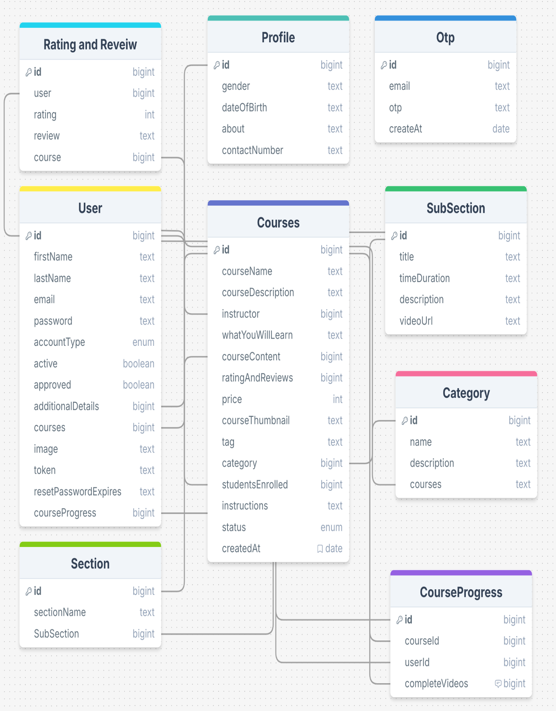

**4.4 FLOW CHART FOR LOGIN**

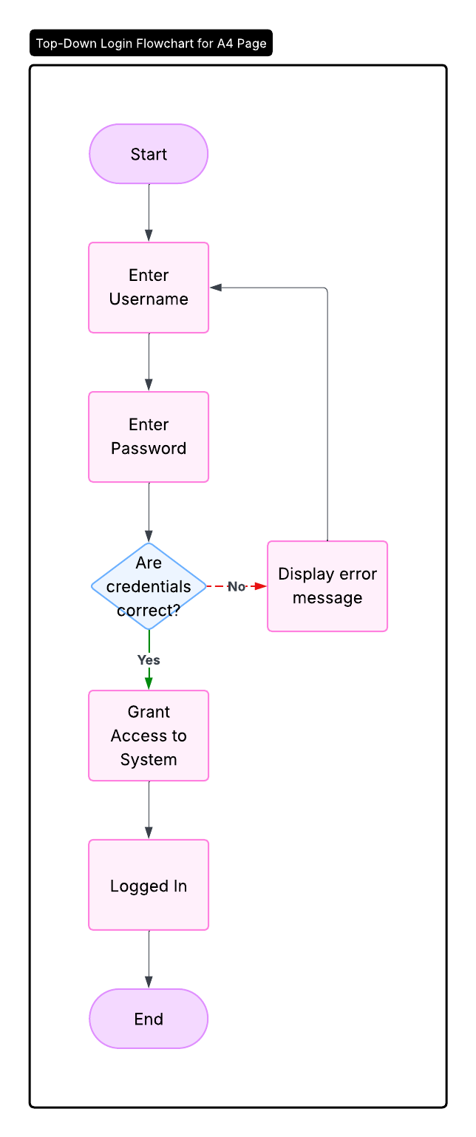

**4.5 FLOW CHART FOR SIGNUP**

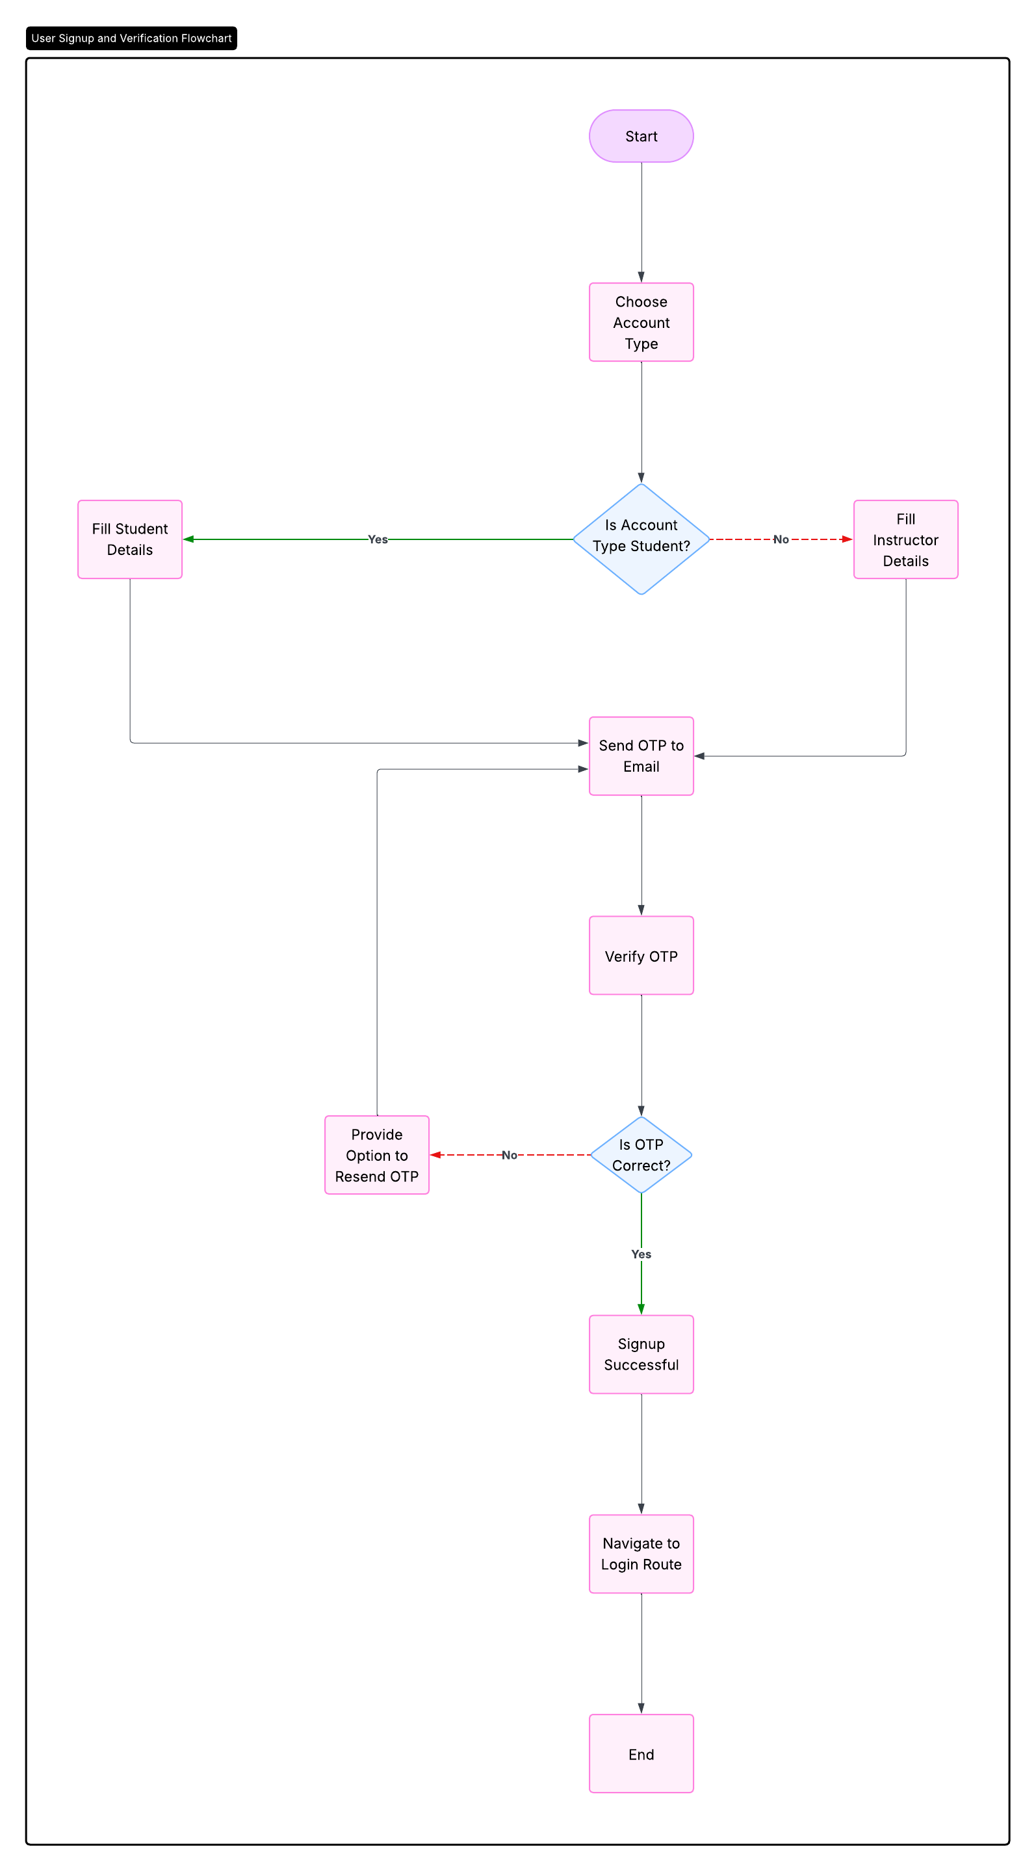

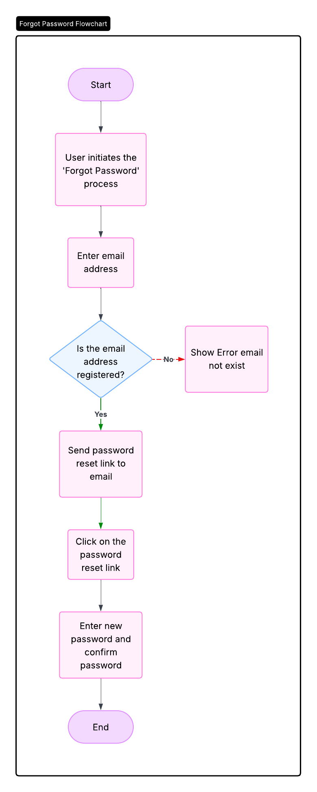**4.6 FLOW CHART FOR FORGOT PASSWORD**

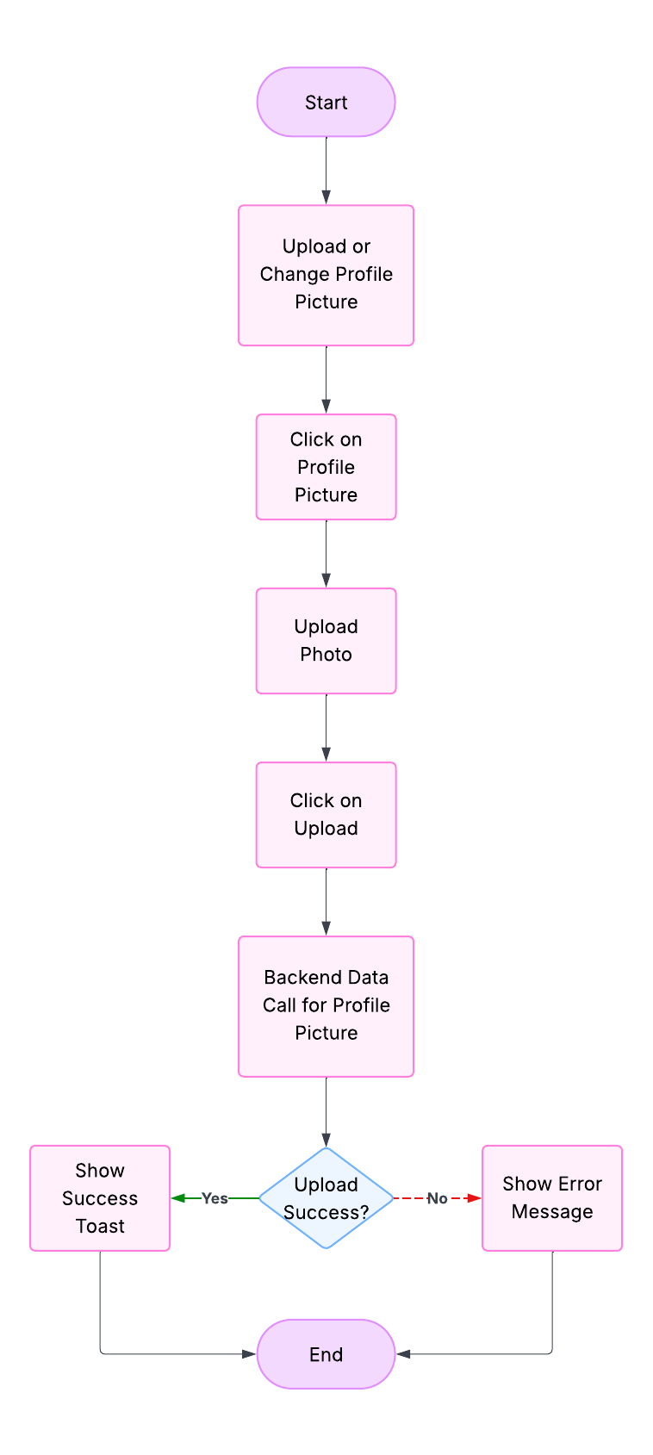**4.7 FLOW CHART FOR UPLOAD OR CHANGE PHOTO**

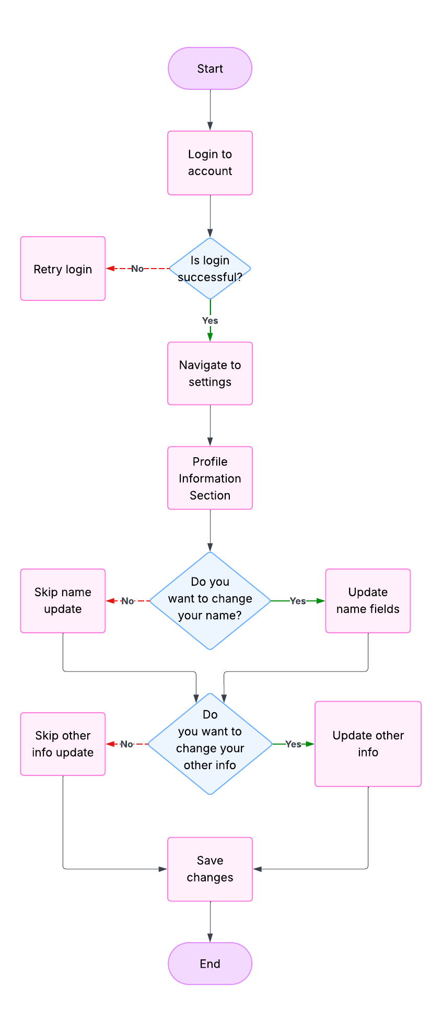**4.8 FLOW CHART FOR CHANGE PERSONAL DETAILS**

**4.9 FLOW CHART FOR CHANGE PASSWORD**

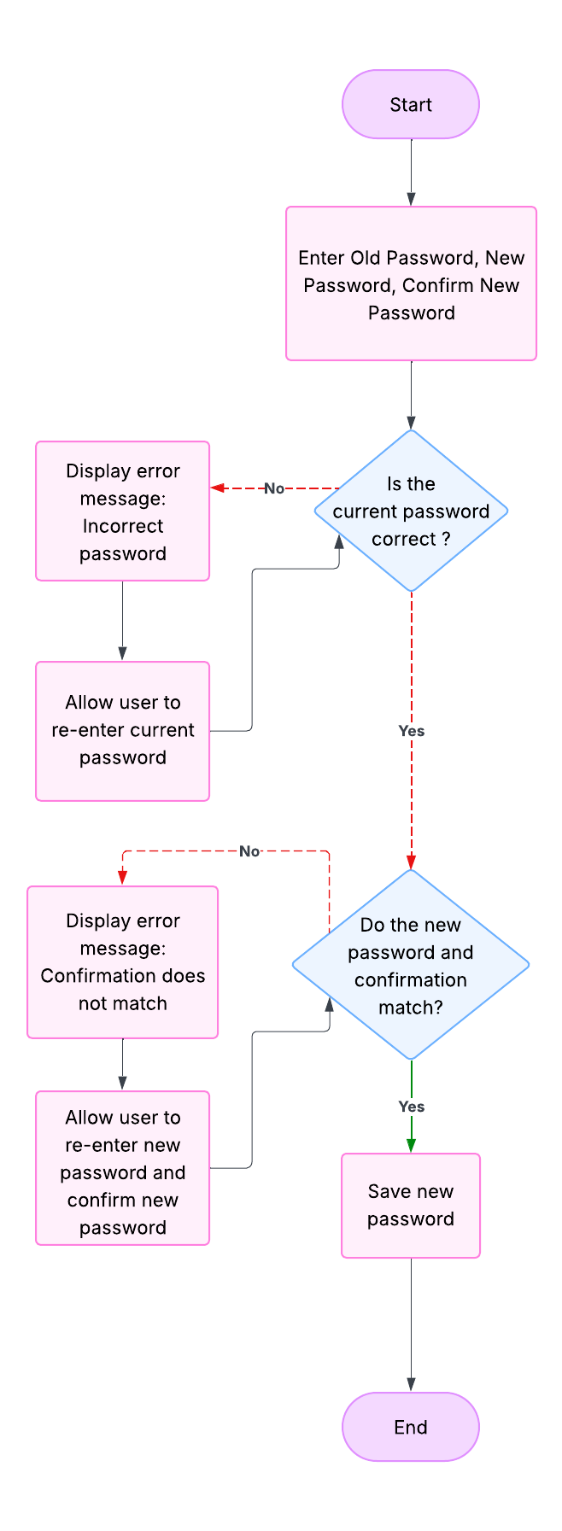

**4.10 FLOW CHART FOR LOGOUT**

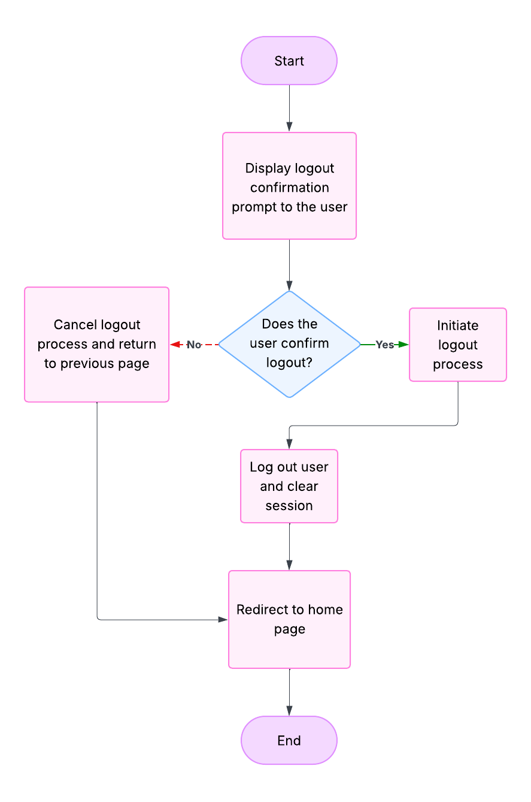

**4.11 FLOW CHART FOR SHOW CATEOGRIES (ONLY ADMIN)**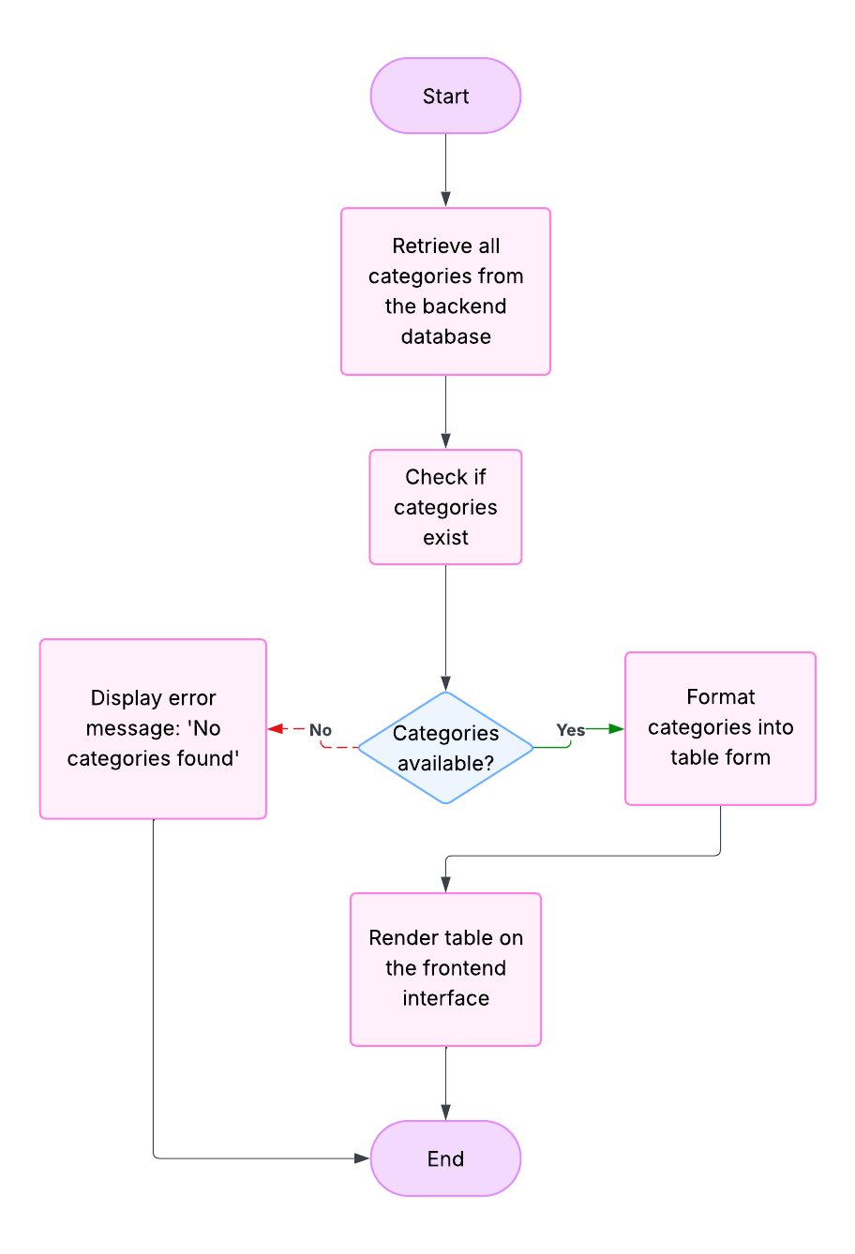

**4.12 FLOW CHART FOR ADD CATEOGRIES (ONLY ADMIN)**

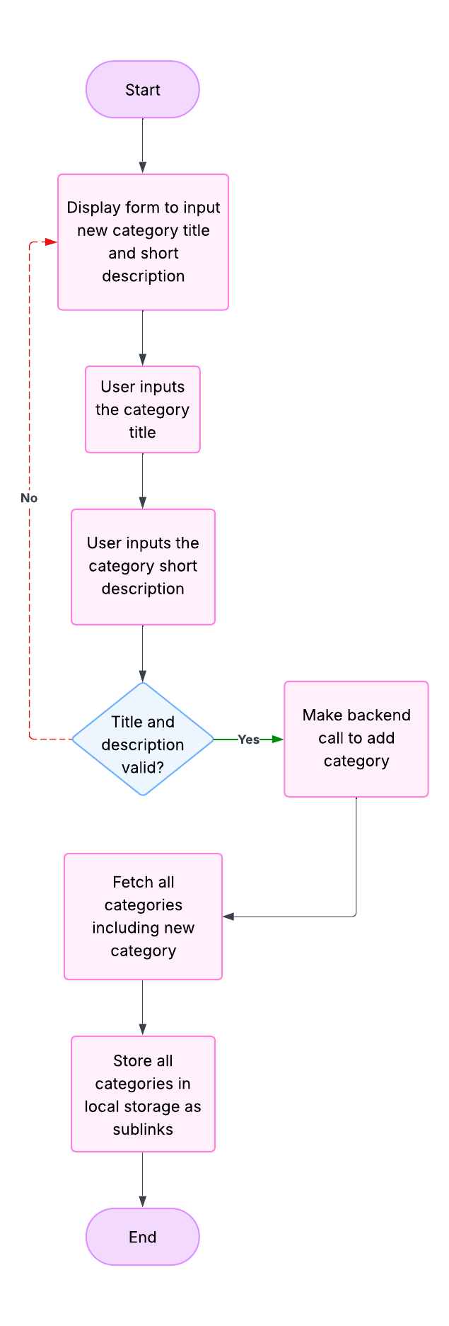

**4.13 FLOW CHART FOR SHOW ALL USERS (ONLY ADMIN)**

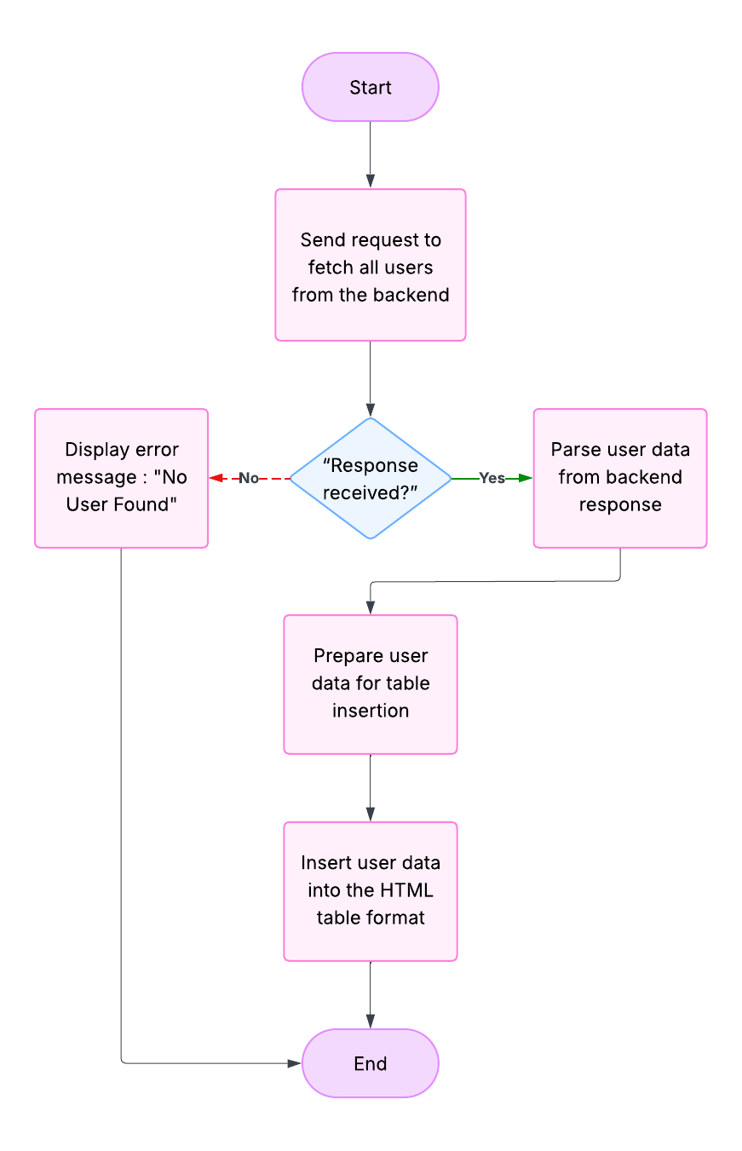

**4.14 FLOW CHART FOR ALL COURSES (ONLY ADMIN & INSTRUCTOR)**

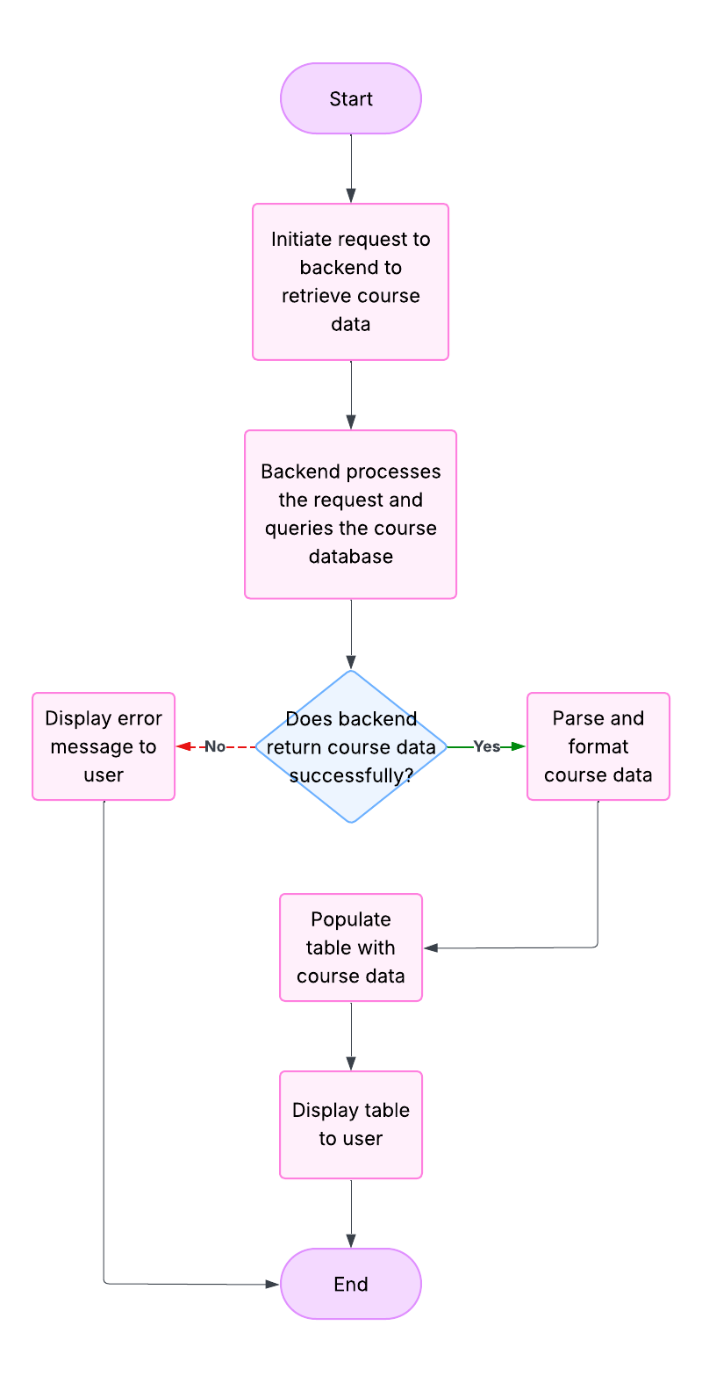

**4.15 FLOW CHART FOR ADD COURSE (ONLY INSTRUCTOR)**

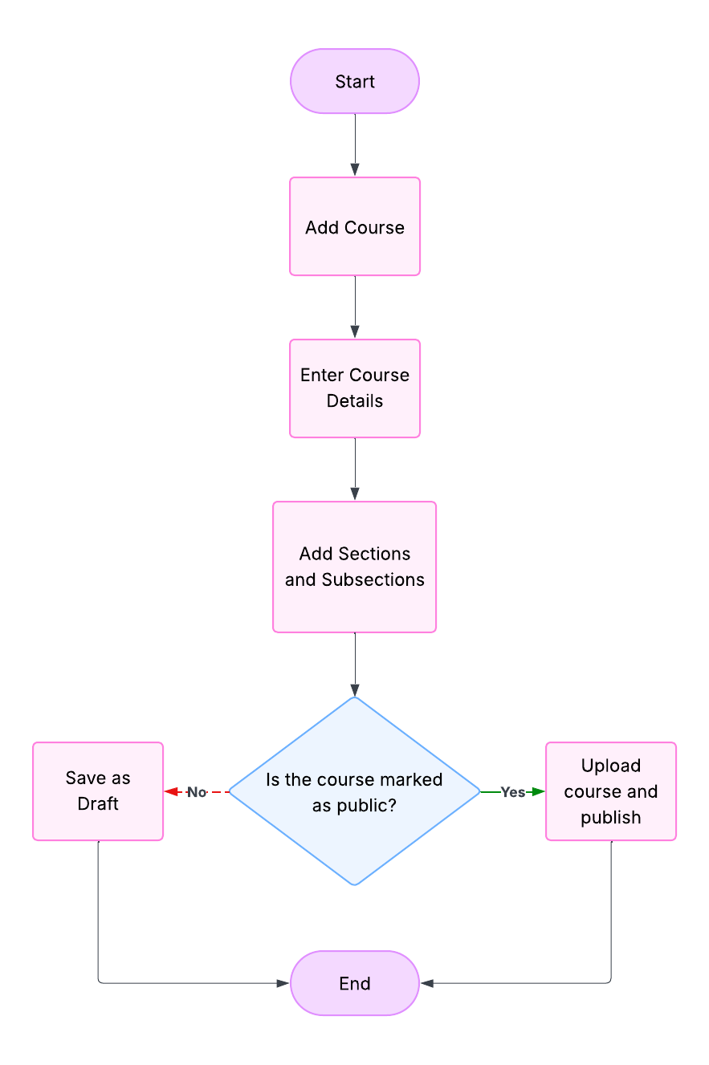

**4.16 FLOW CHART FOR ENROLLED COURSE (ONLY USER)**

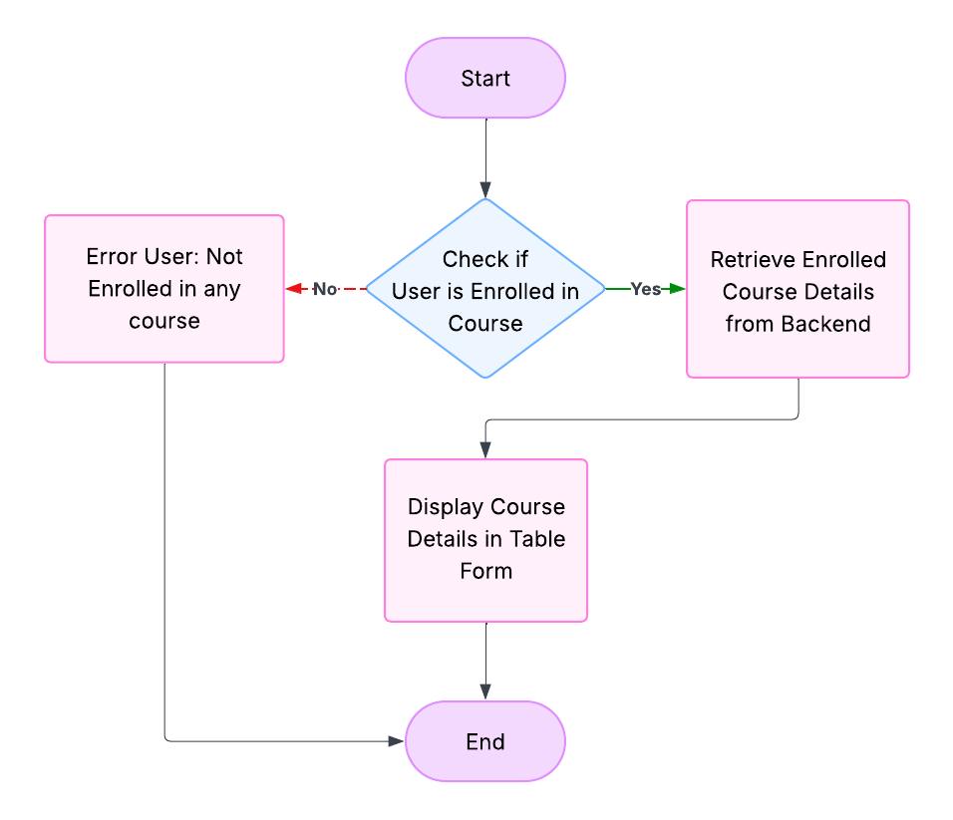

**4.17 FLOW CHART FOR BUY CART COURSES (ONLY USER)**

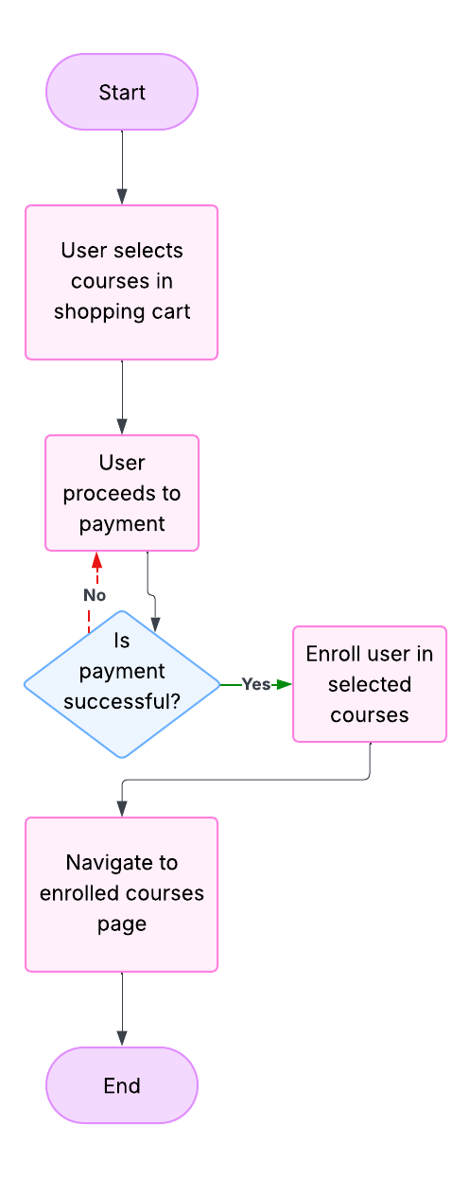

**4.18 FLOW CHART FOR NAVBAR CATALOG**

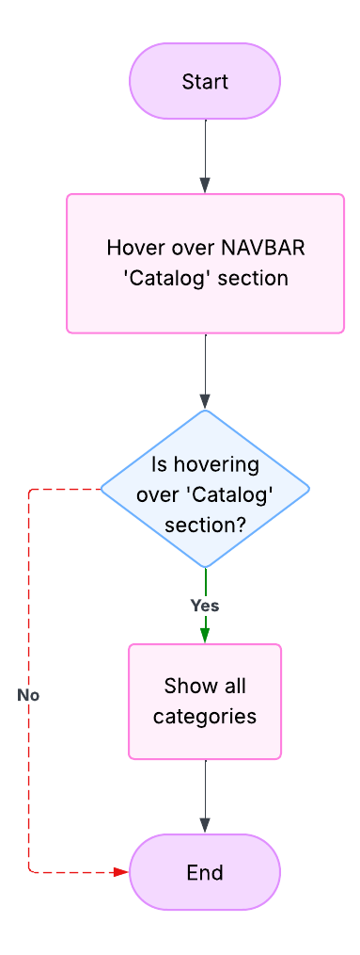

**4.19 FLOW CHART FOR CATEGORY ALL CORUSES**

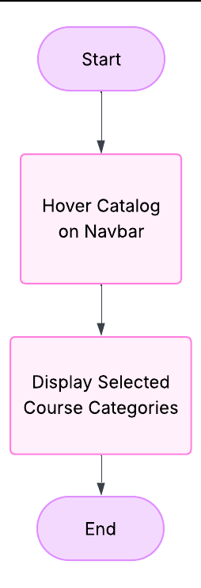

**4.20 FLOW CHART FOR VIEW SINGLE CORUSES**

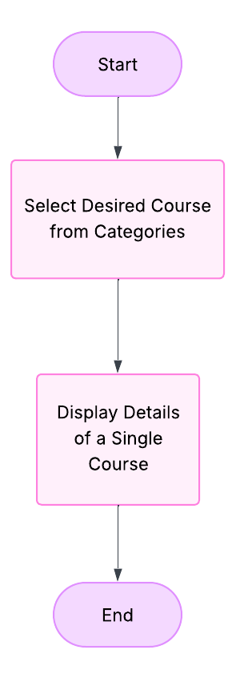

**4.21 FLOW CHART FOR CONTACT US FORM**

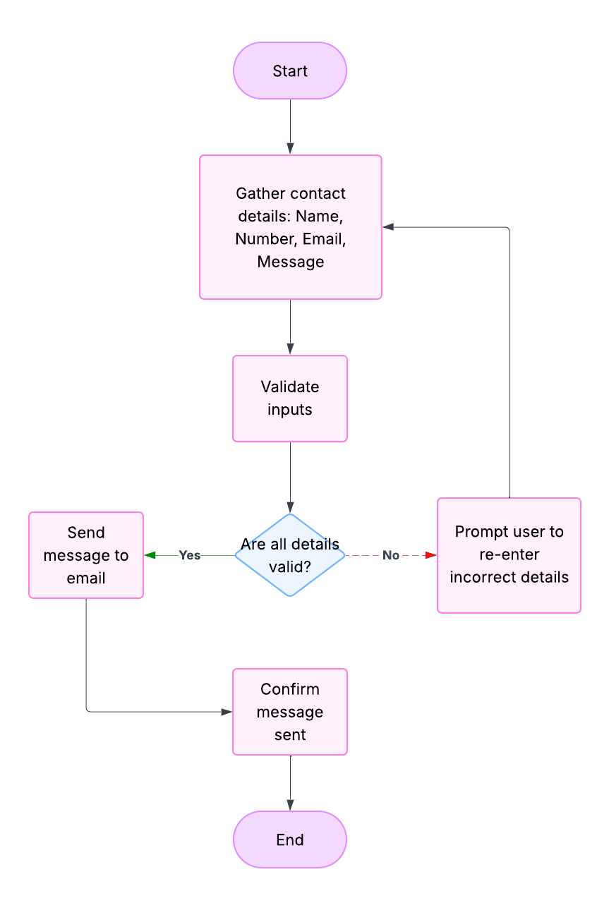

**4.22 FLOW CHART FOR SEARCH ANY COURSE**

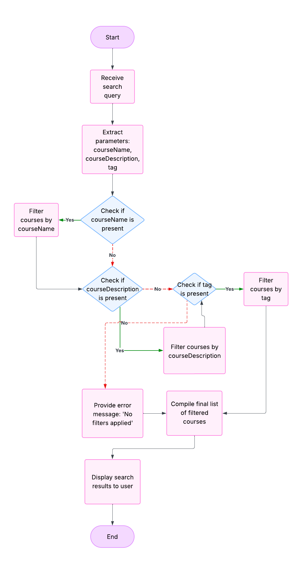

**SYSTEM IMPLEMENTATION**

**5.1 Screenshots of Home page**

Light Mode: - Dark Mode: -

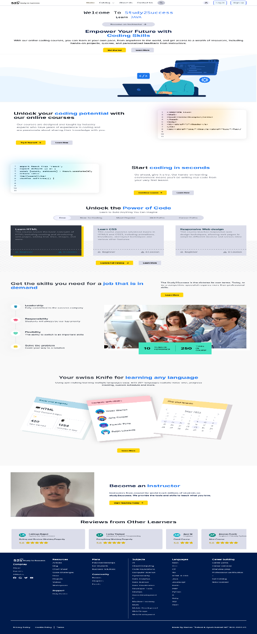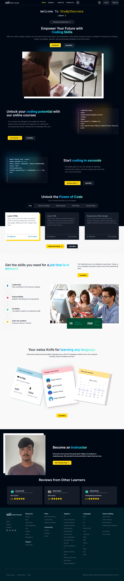

**5.2 Screenshots of Home Page when Logged in**

Light Mode: Dark Mode: -

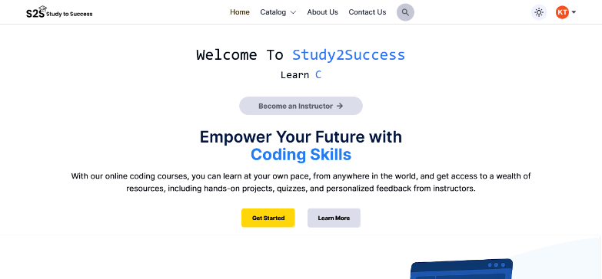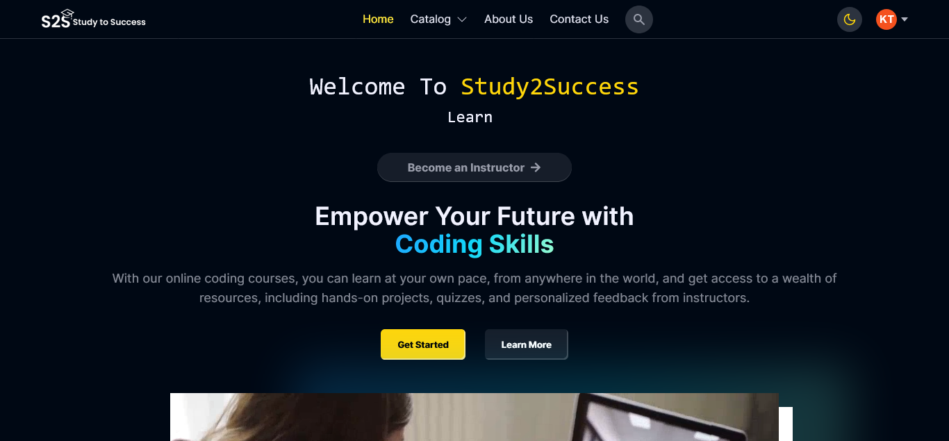

**5.3 Screenshots of Course Page**

Light Mode: - Dark Mode: -

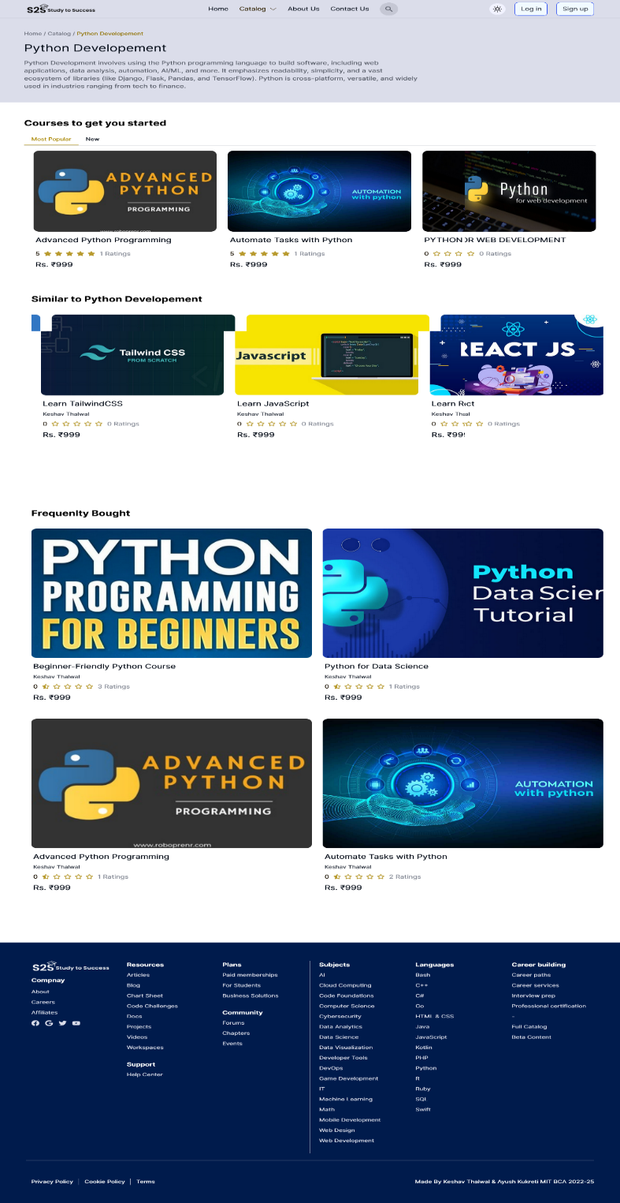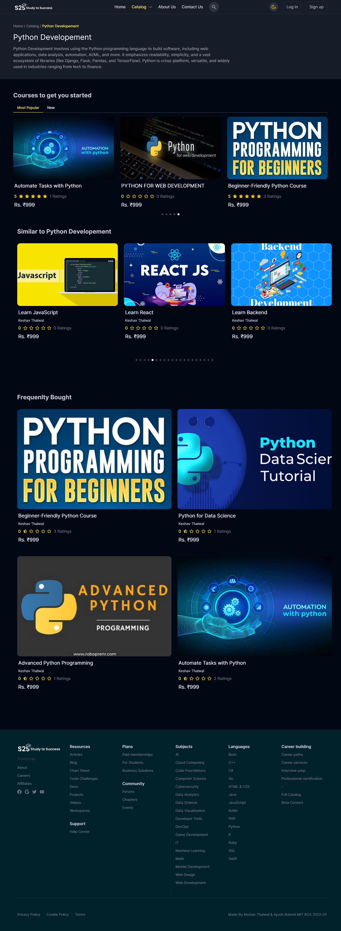

**5.4 Screenshots of View Course Page**

Light Mode: Dark Mode: -

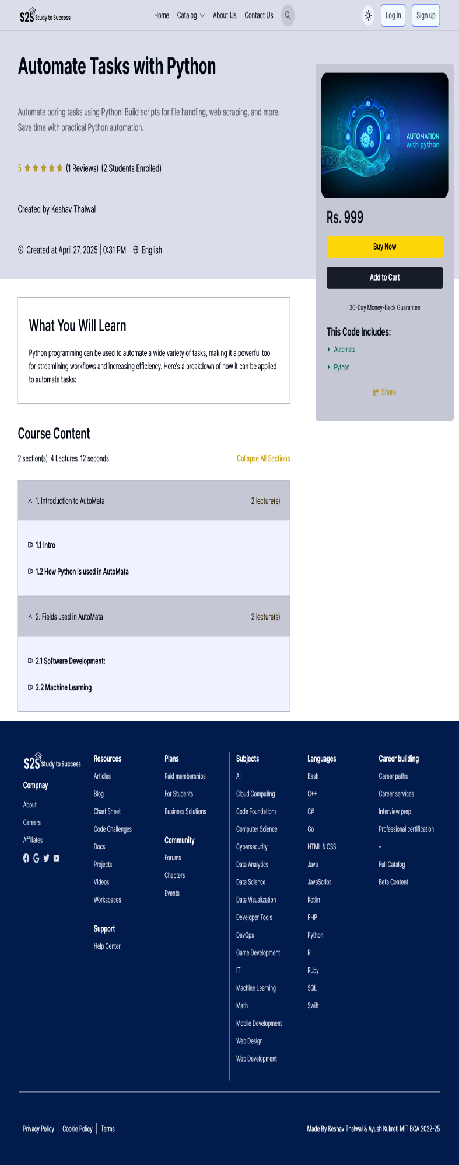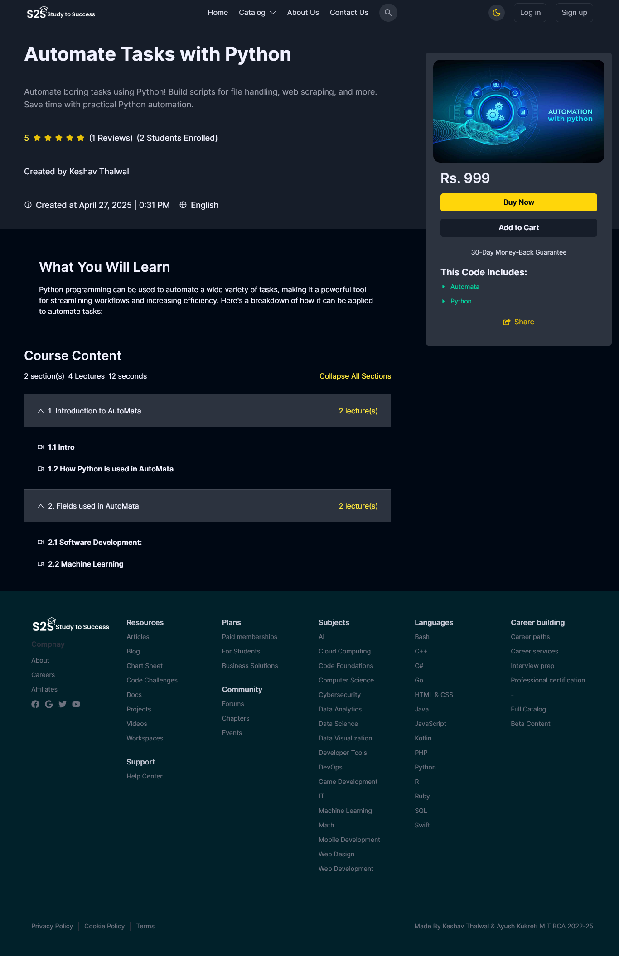

**5.5 Screenshots of About Page**

Light Mode: Dark Mode: -

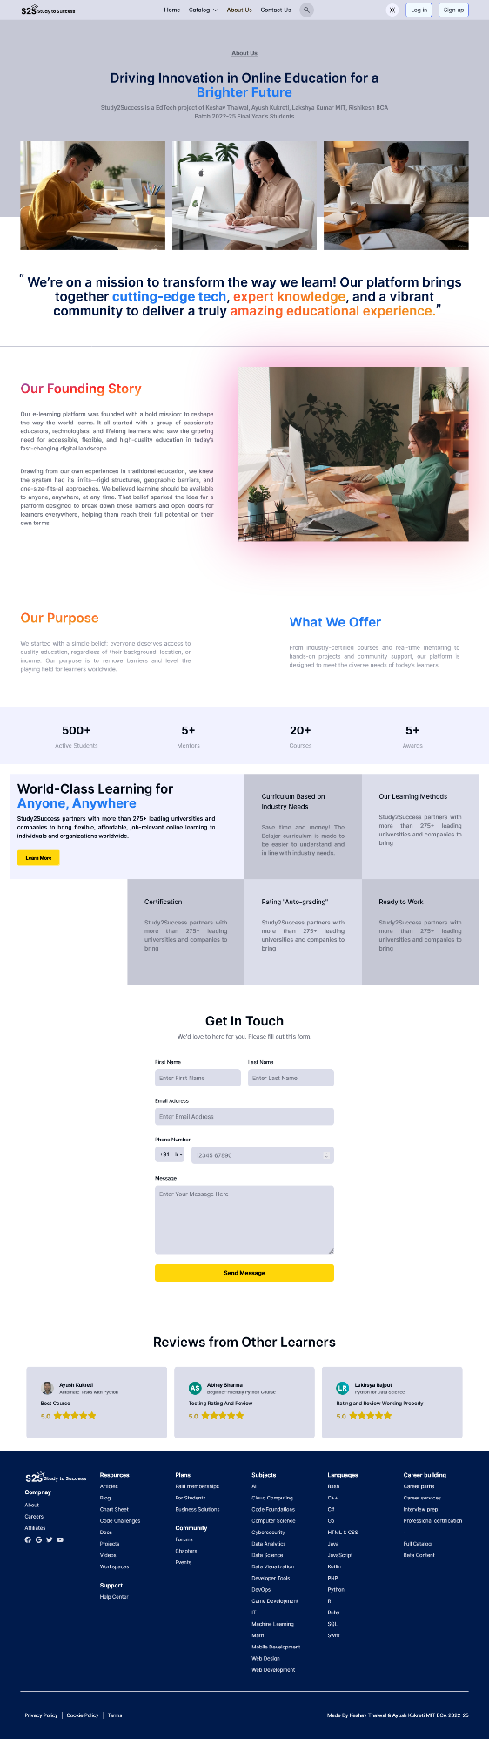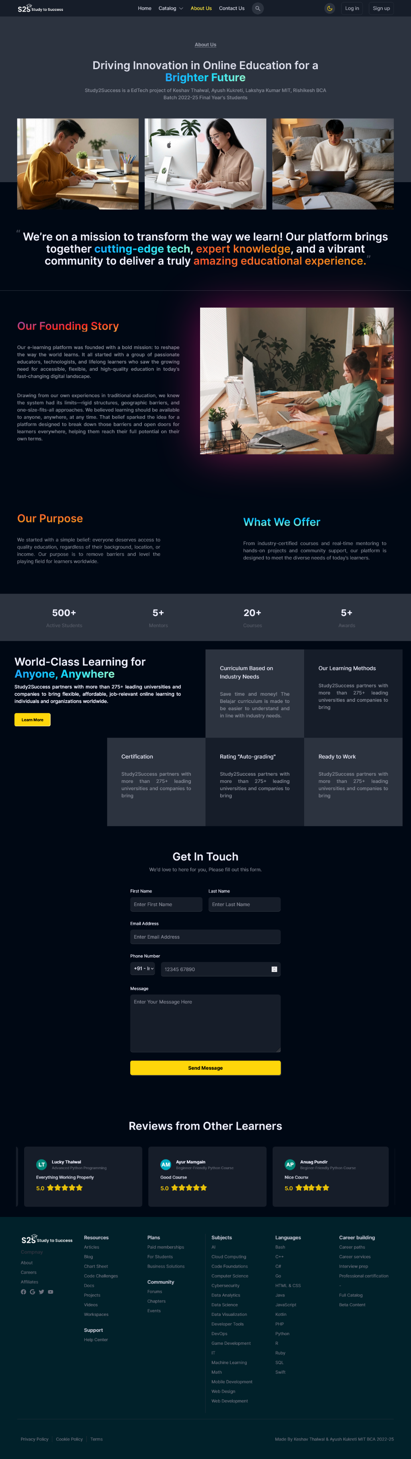

**5.6 Screenshots of Contact Us Page**

Light Mode: Dark Mode: -

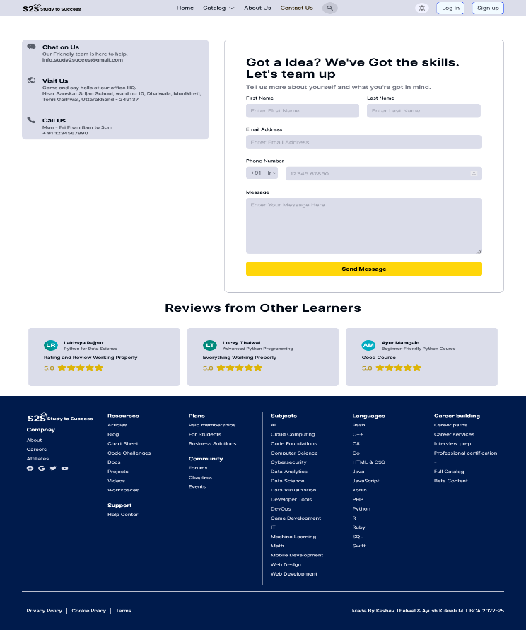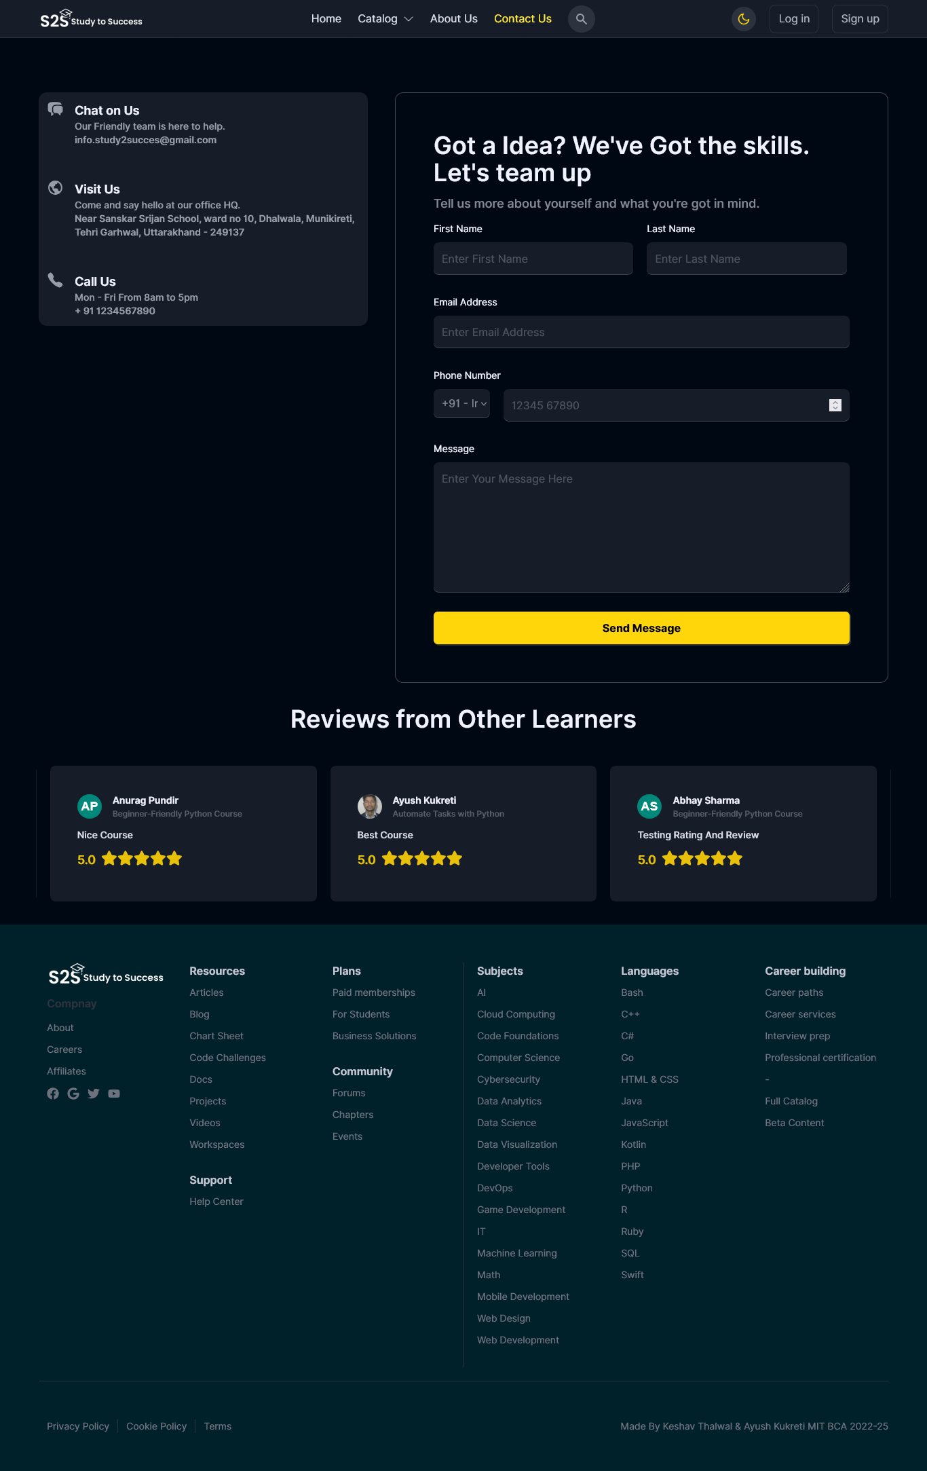

**5.7 Screenshots of Search Page**

Light Mode: Dark Mode: -

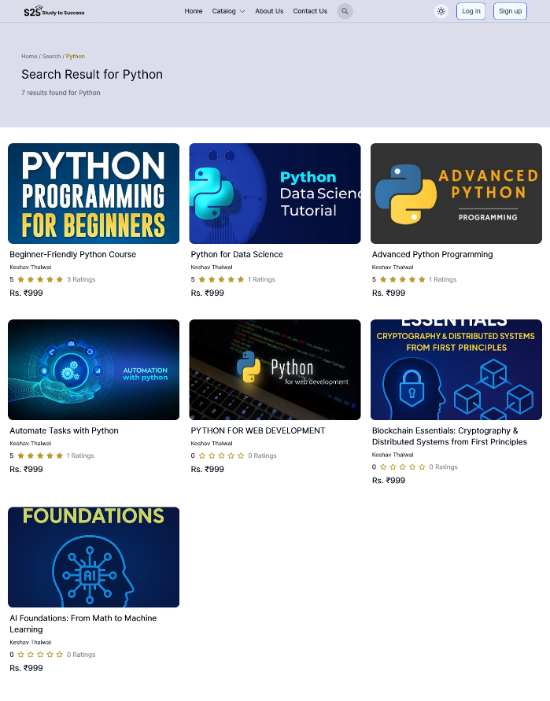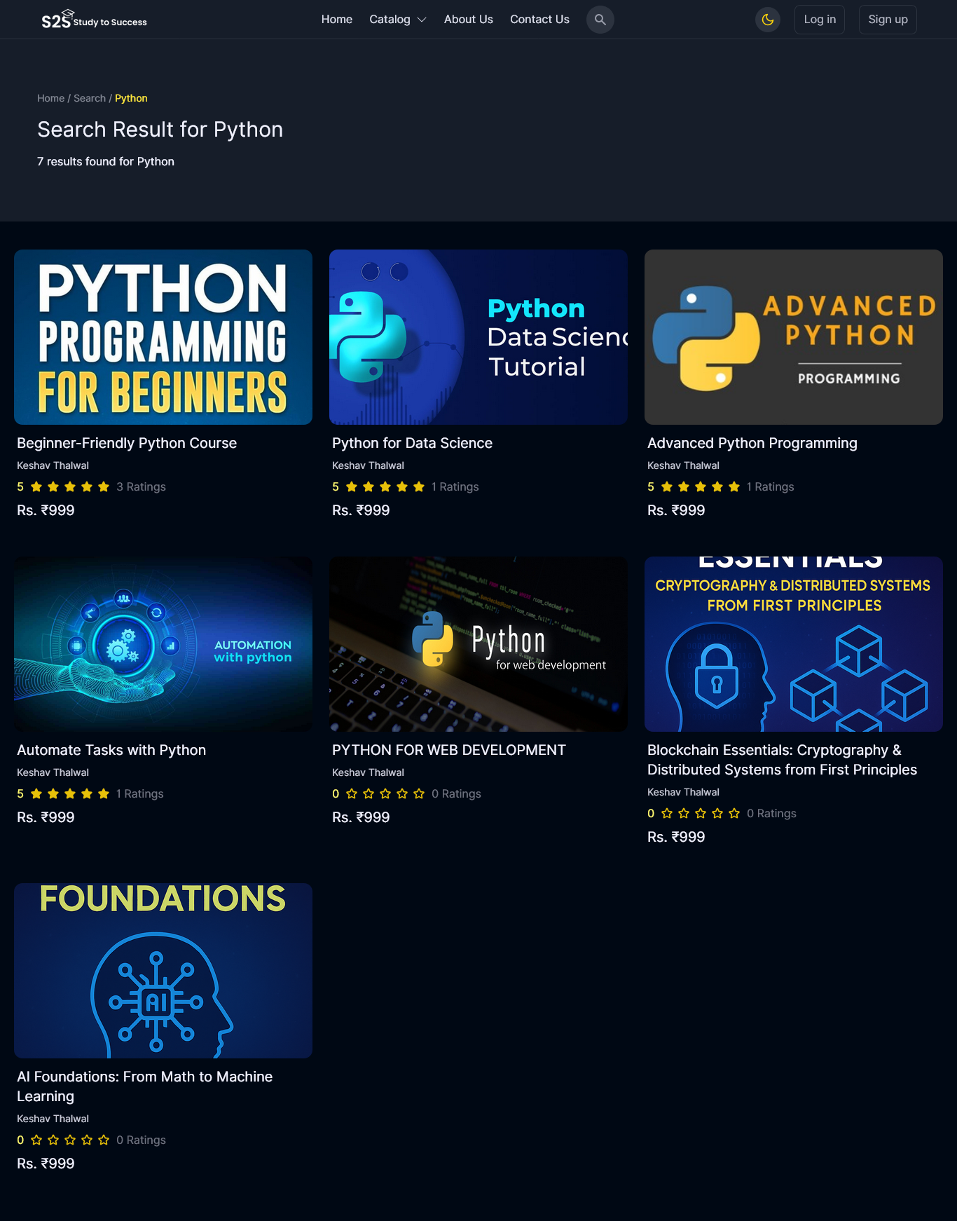

**5.8 Screenshots of Login Page**

Light Mode: Dark Mode: -

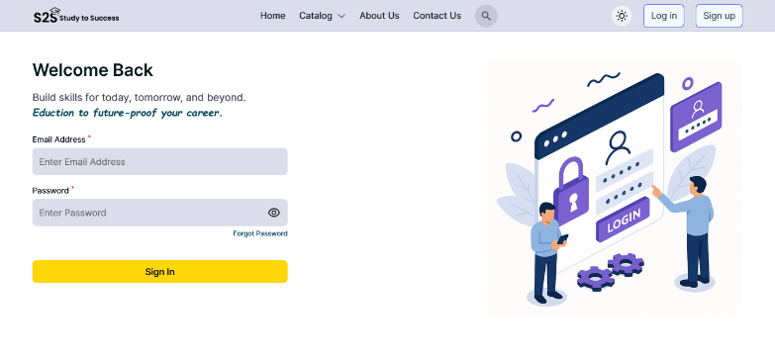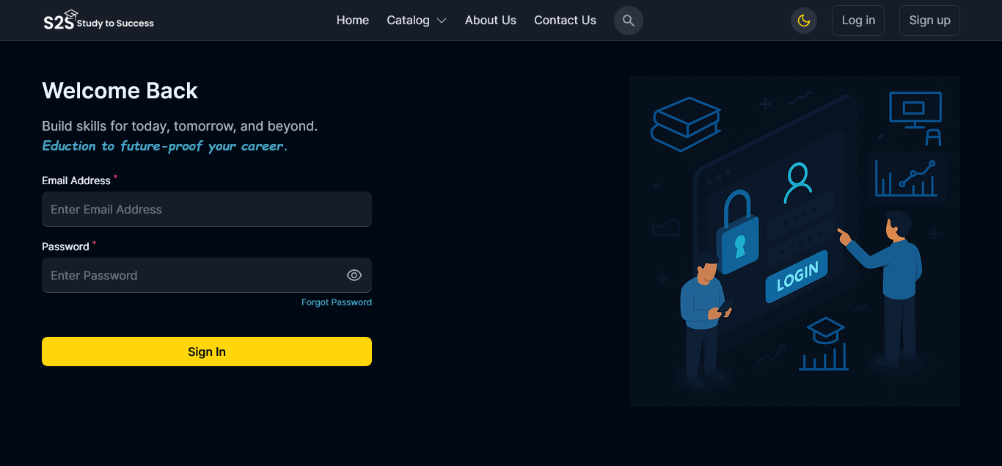

**5.9 Screenshots of Signup Page**

Light Mode: Dark Mode: -

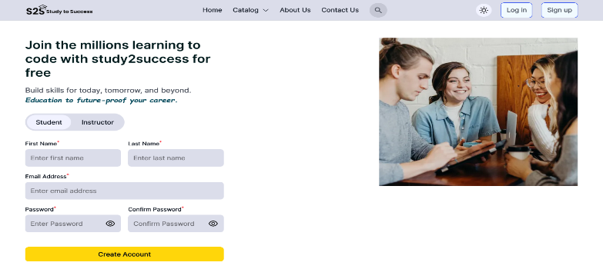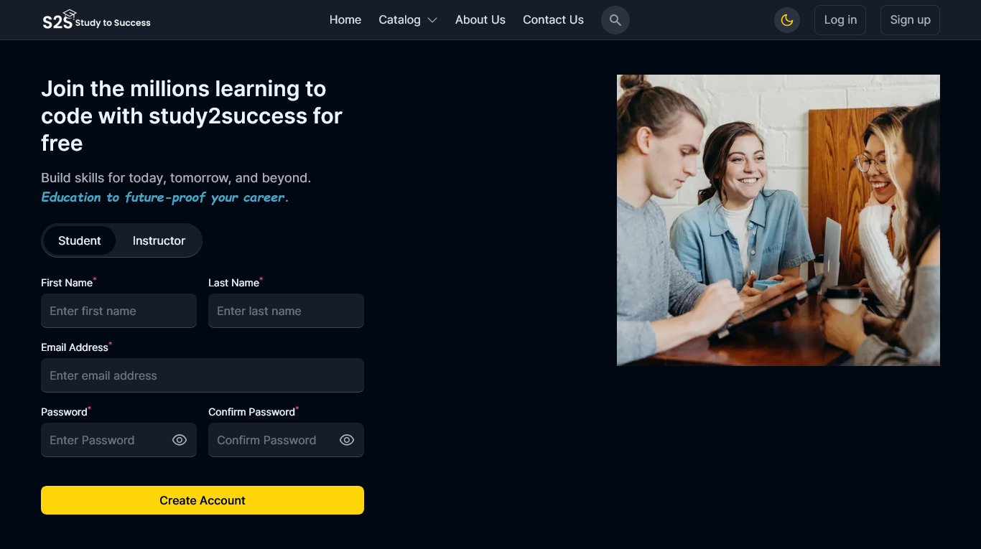

**5.10 Screenshots of Forgot Password Link Page**

Light Mode: Dark Mode: -

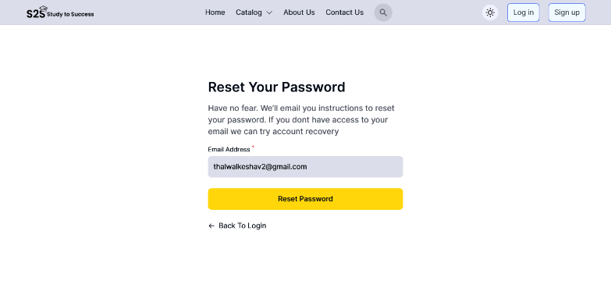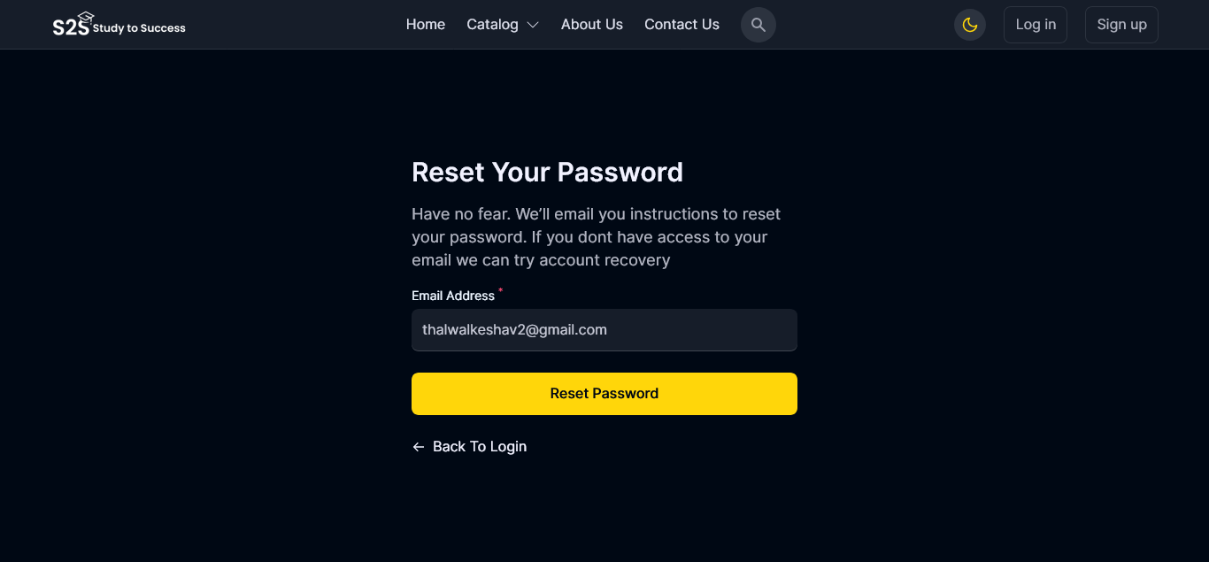

**5.11 Screenshots of New Password Page**

Light Mode: Dark Mode: -

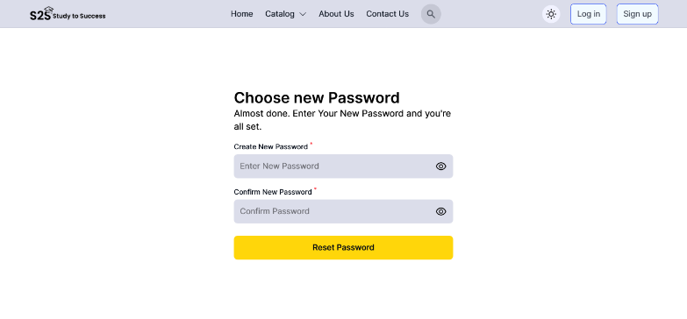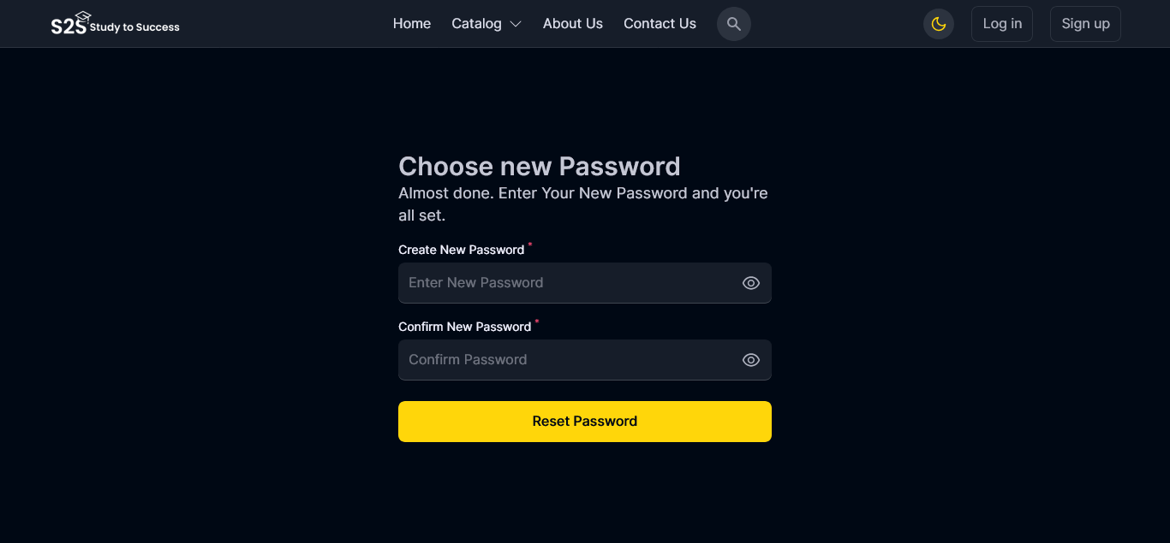

**5.12 Screenshots of My Profile Page**

Light Mode: Dark Mode: -

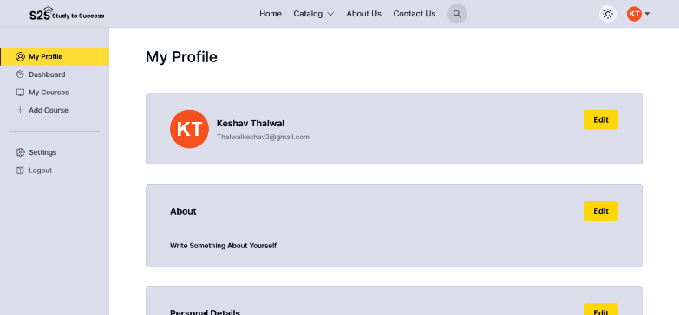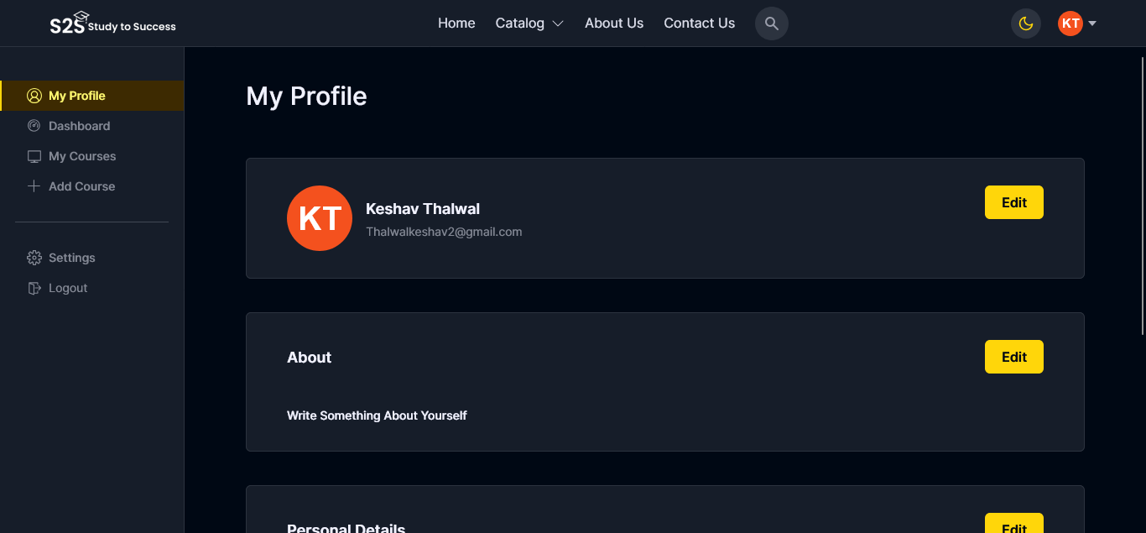

**5.13 Screenshots of Dashboard (Instructor) Page**

Light Mode: Dark Mode: -

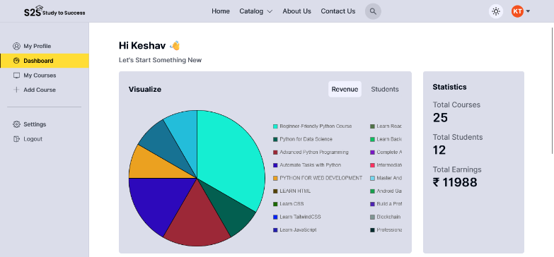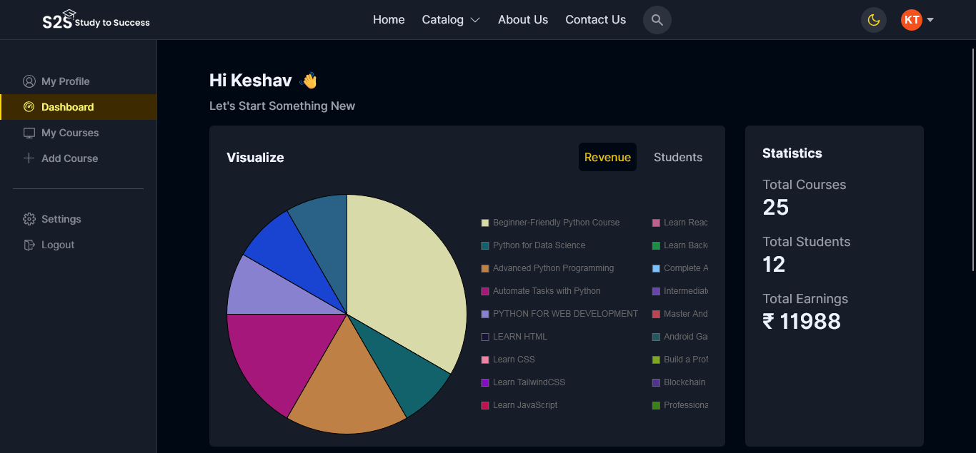

**5.14 Screenshots of My Courses (Instructor) Page**

Light Mode: Dark Mode: -

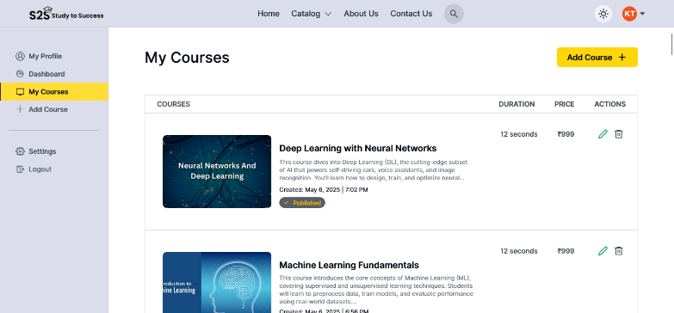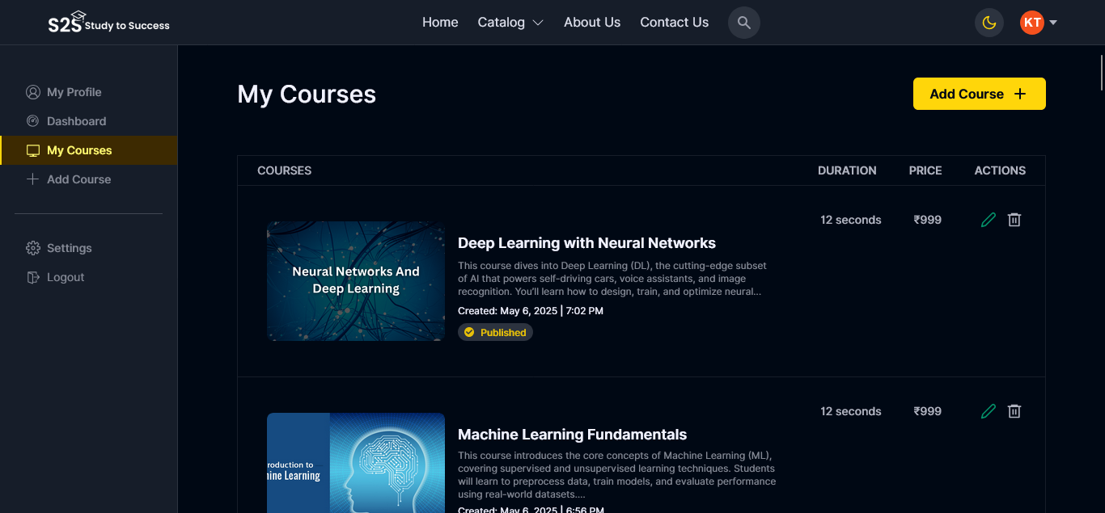

**5.15 Screenshots of Add Course Course Information (Instructor) Page**

Light Mode: Dark Mode: -

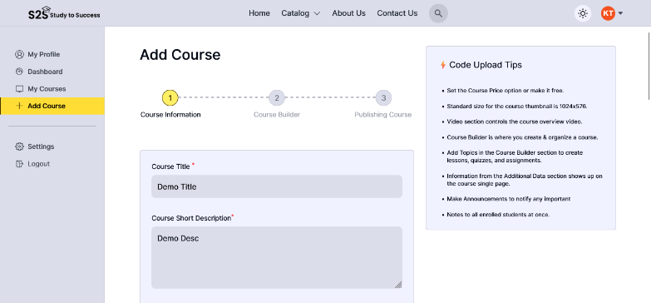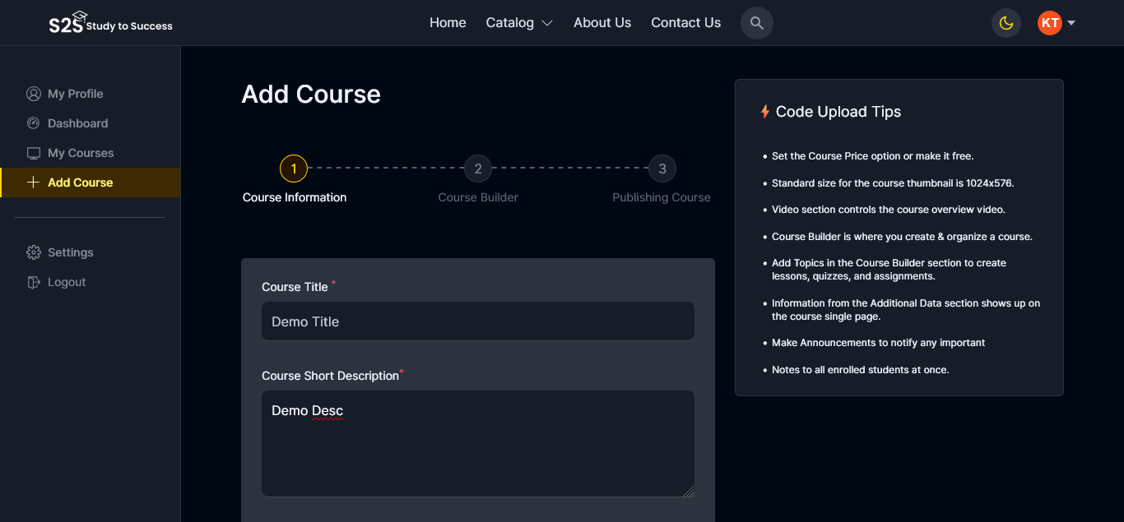

**5.16 Screenshots of Creating Section (Instructor) Page**

Light Mode: Dark Mode: -

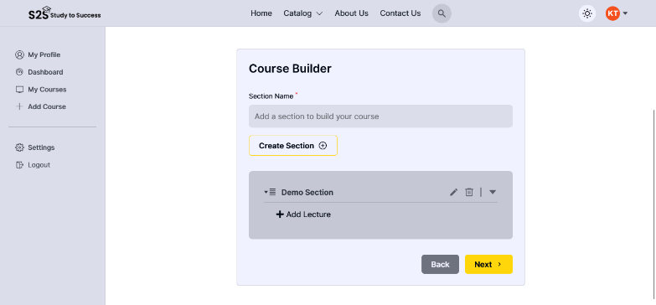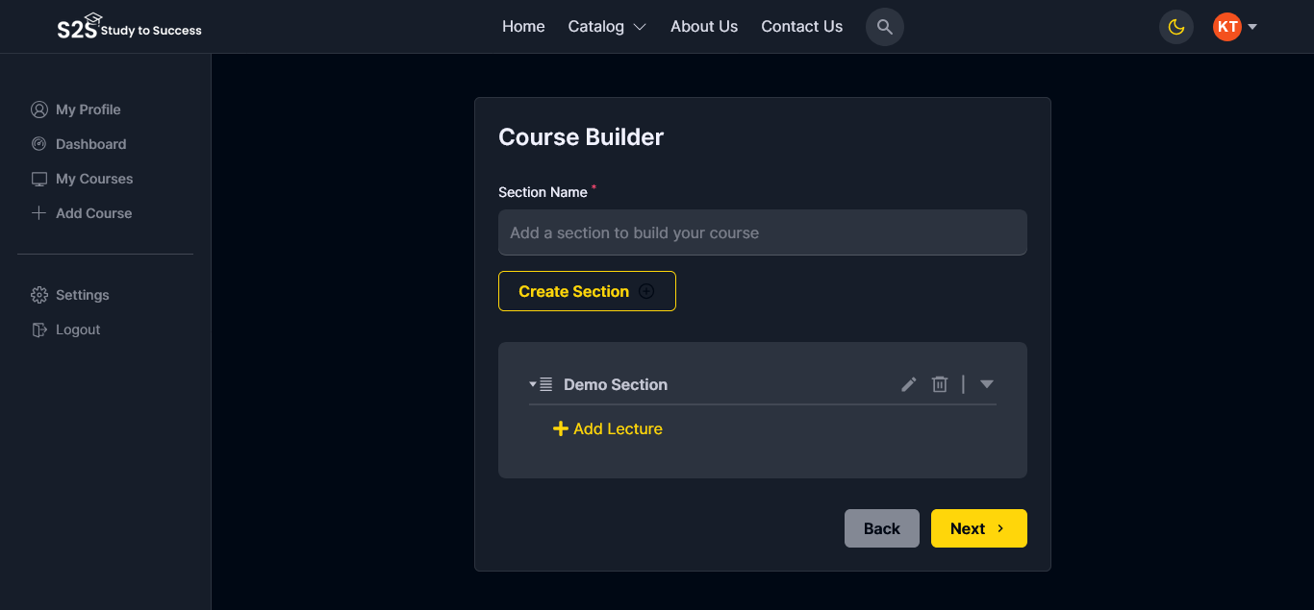

**5.17 Screenshots of Sub-Section (Instructor) Page**

Light Mode: Dark Mode: -

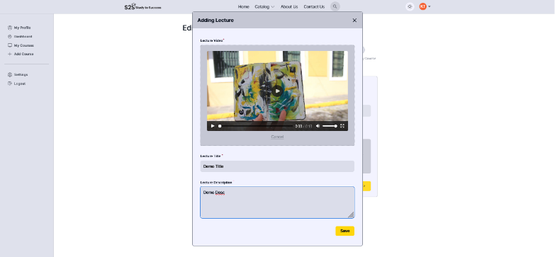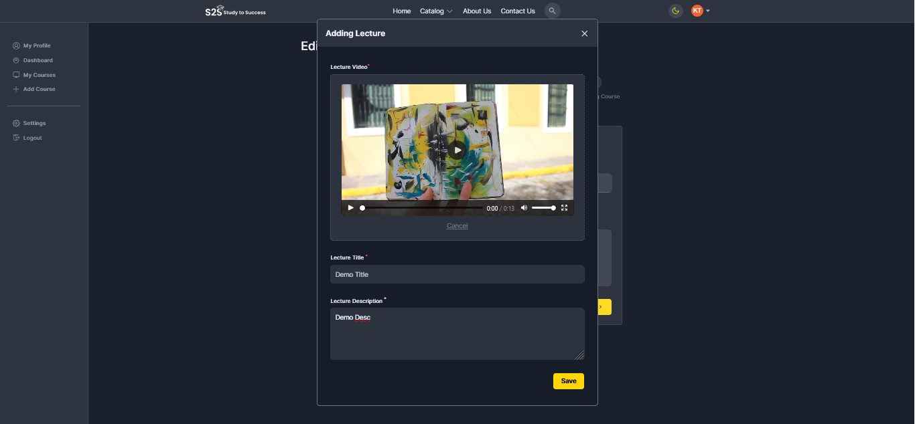

**5.18 Screenshots of Publish Course (Instructor) Page**

Light Mode: Dark Mode: -

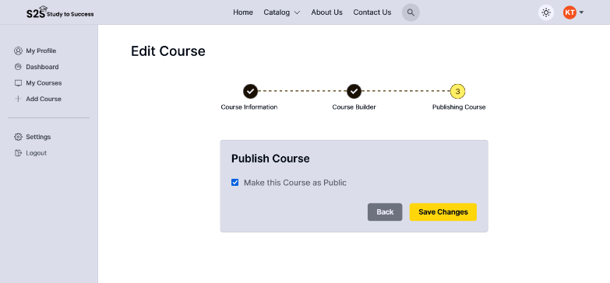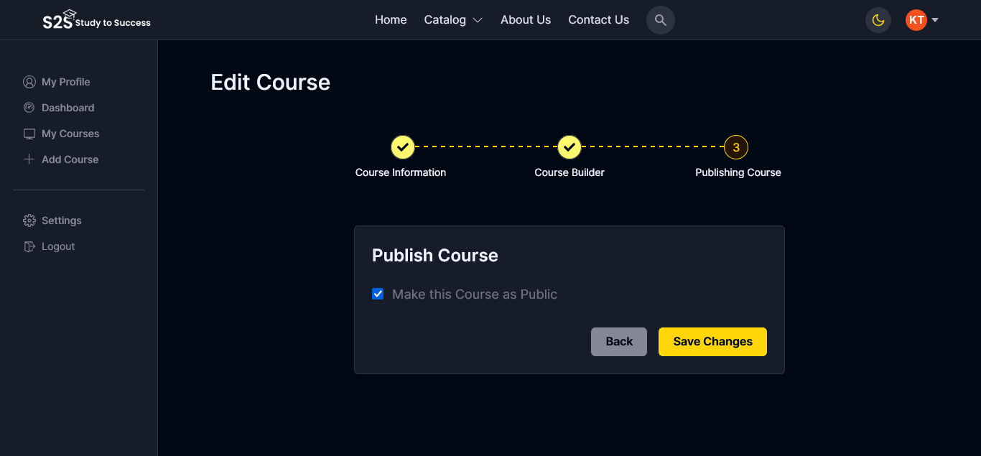

**5.19 Screenshots of Edit Profile Photo Page**

Light Mode: Dark Mode: -

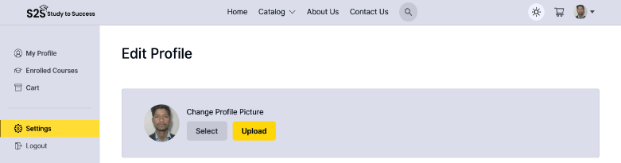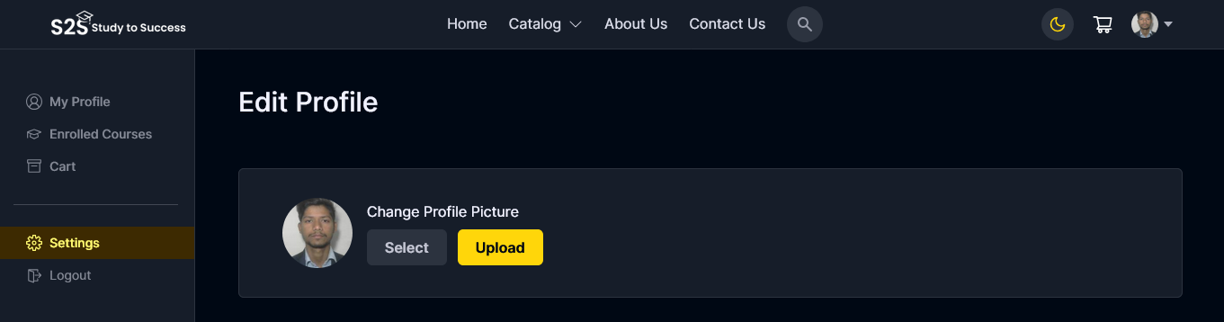

**5.20 Screenshots of Edit Personal Information Page**

Light Mode: Dark Mode: -

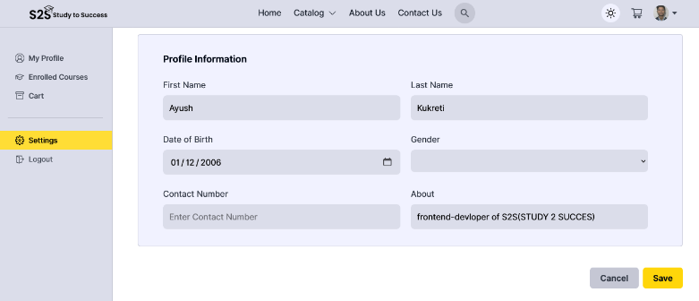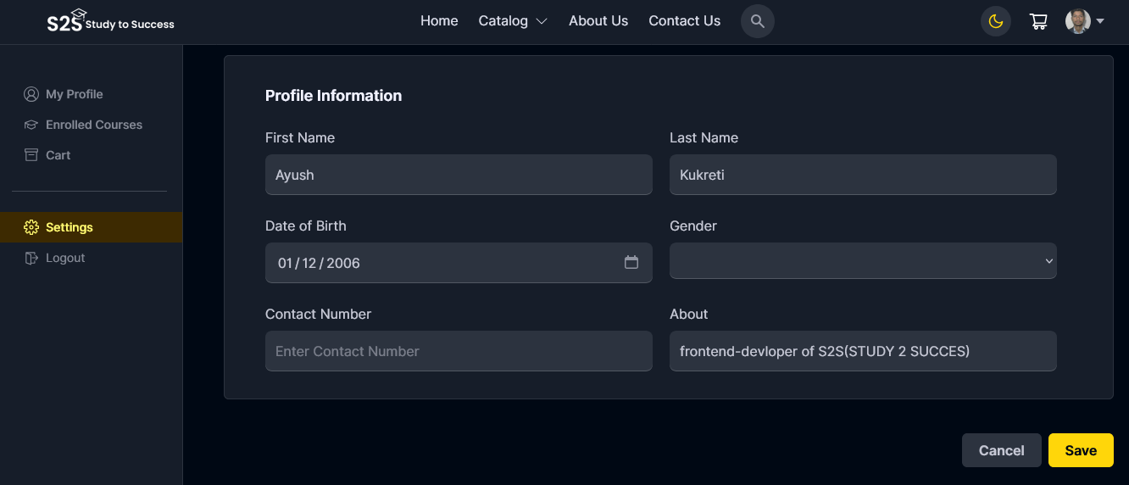

**5.21 Screenshots of Change Password & Delete Account Page**

Light Mode: Dark Mode: -

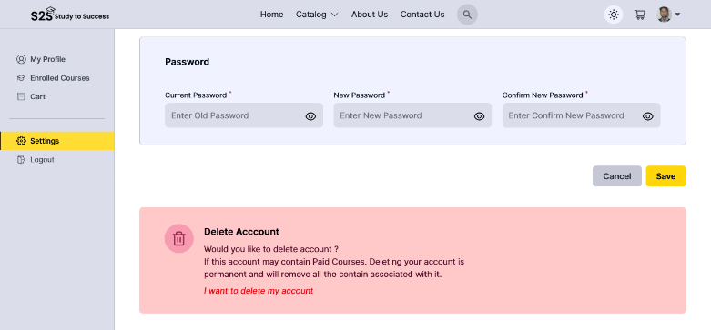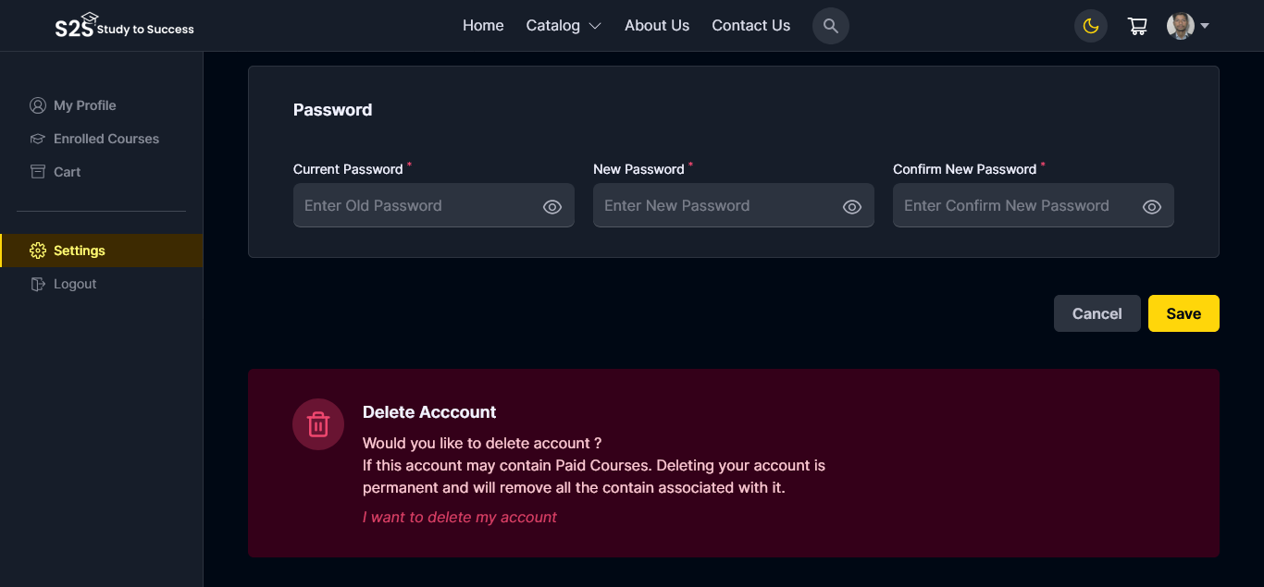

**5.22 Screenshots of Enrolled Course (Student) Page**

Light Mode: Dark Mode: -

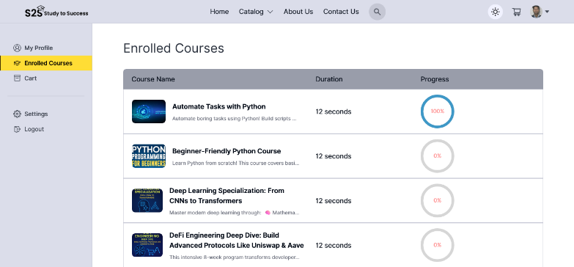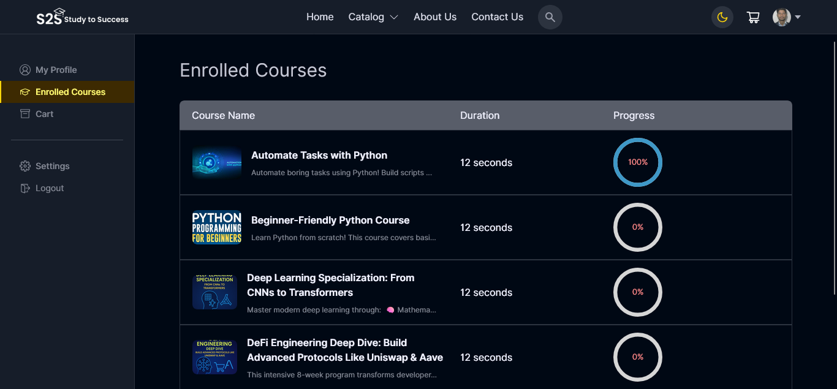

**5.23 Screenshots of View Enrolled Course (Student) Page**

Light Mode: Dark Mode: -

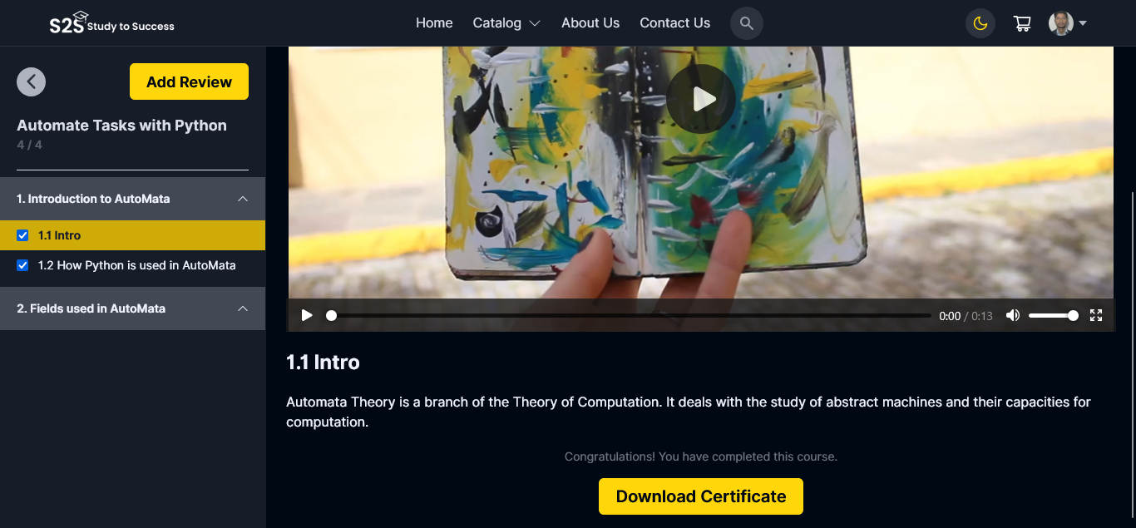

**5.24 Screenshots of After Complete Course Download Certificate (Student) Page**

Light Mode: Dark Mode: -

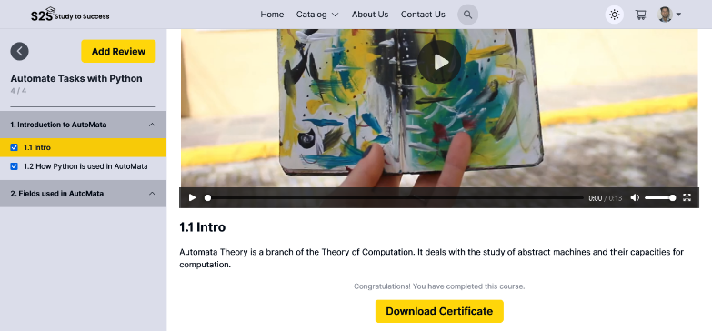

**5.25 Screenshots of Download Certificate Modal (Student) Page**

Light Mode: Dark Mode: -

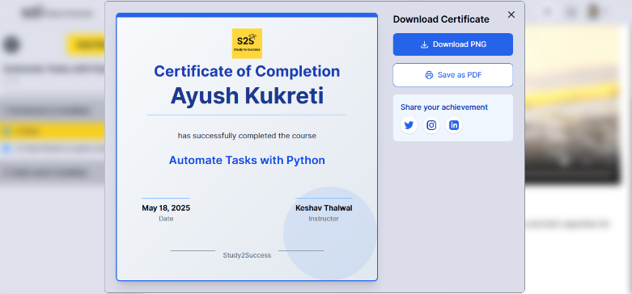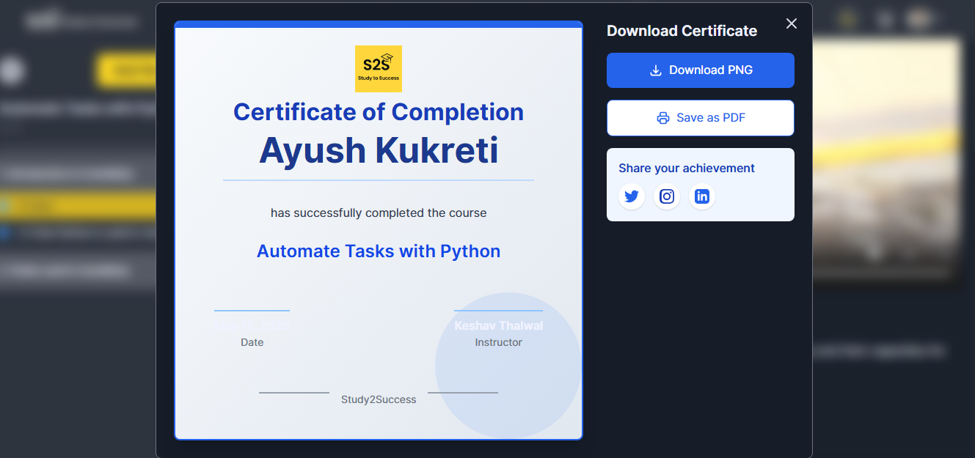

**5.26 Screenshots of Add Review Modal (Student) Page**

Light Mode: Dark Mode: -

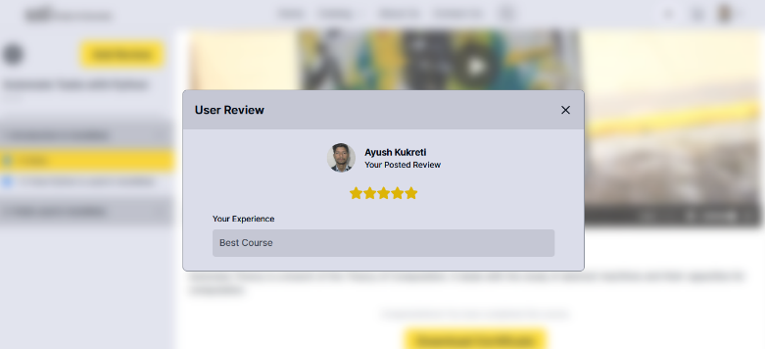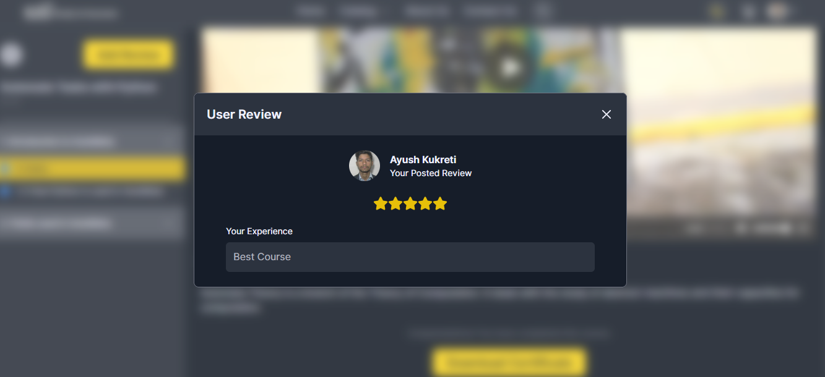

**5.27 Screenshots of Cart (Student) Page**

Light Mode: Dark Mode: -

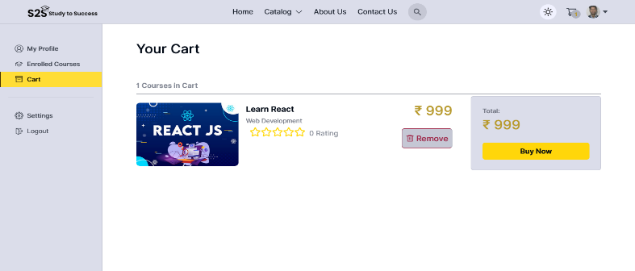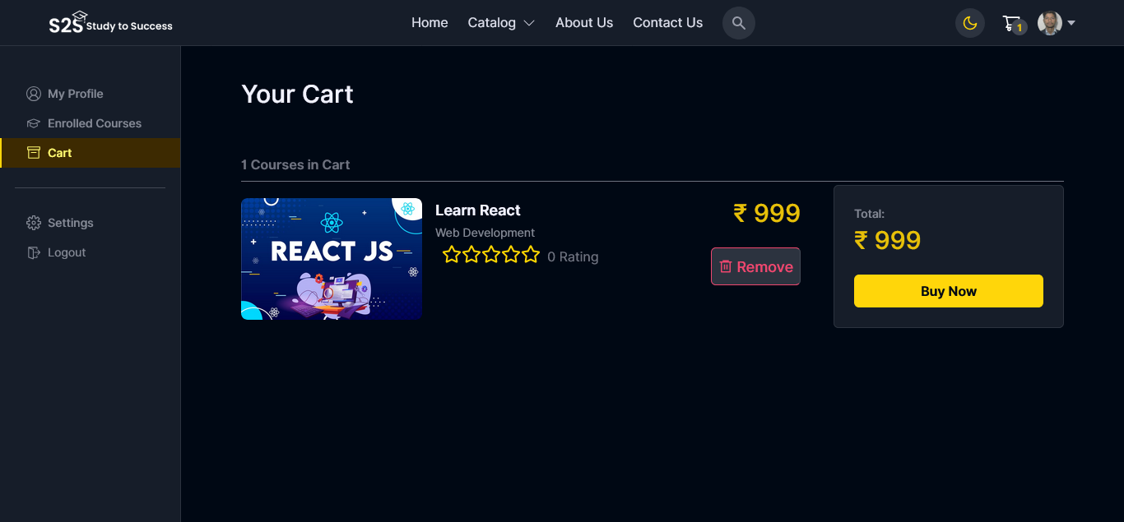

**5.28 Screenshots of Logout Page**

Light Mode: Dark Mode: -

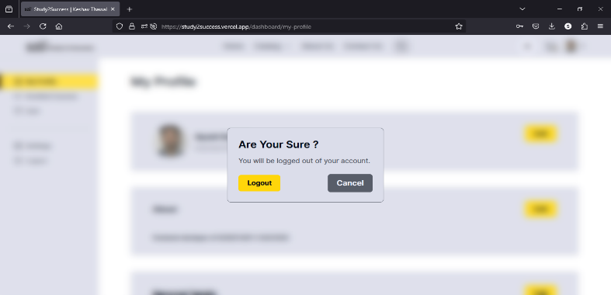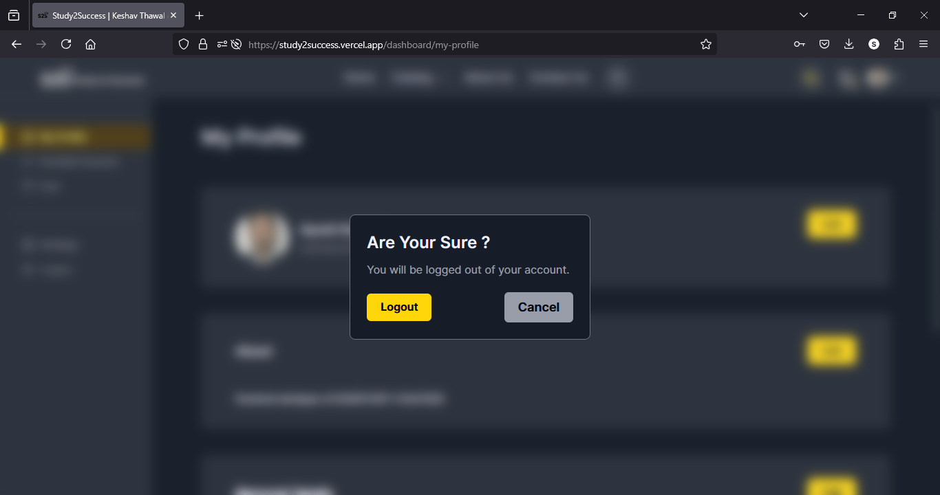

**5.29 Screenshots of Admin Login Page**

Light Mode: Dark Mode: -

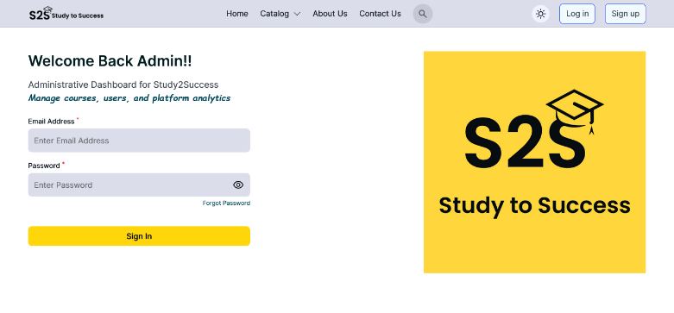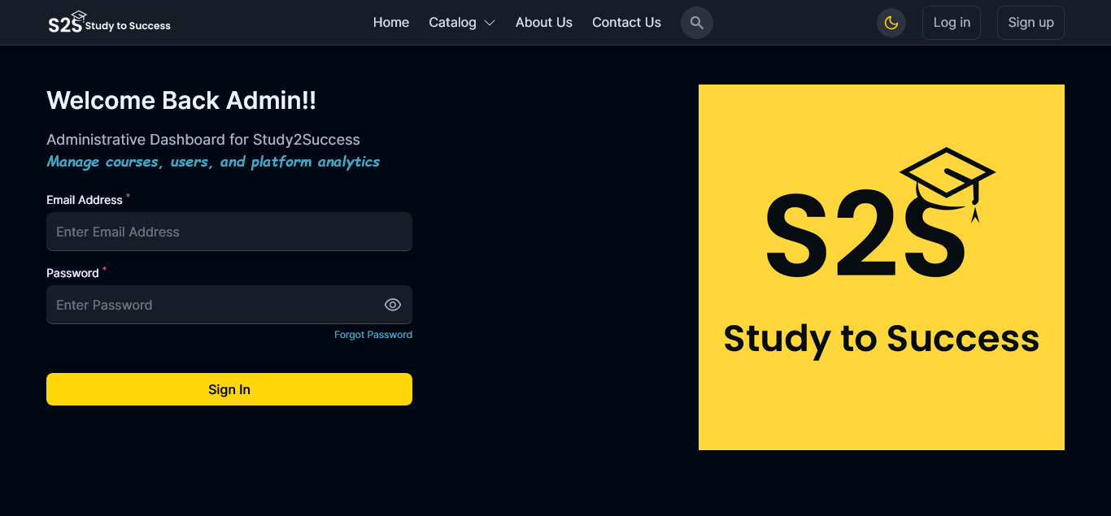

**5.30 Screenshots of Admin Dashboard Page**

Light Mode: Dark Mode: -

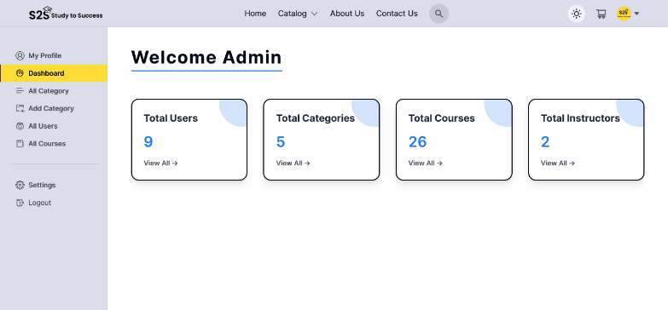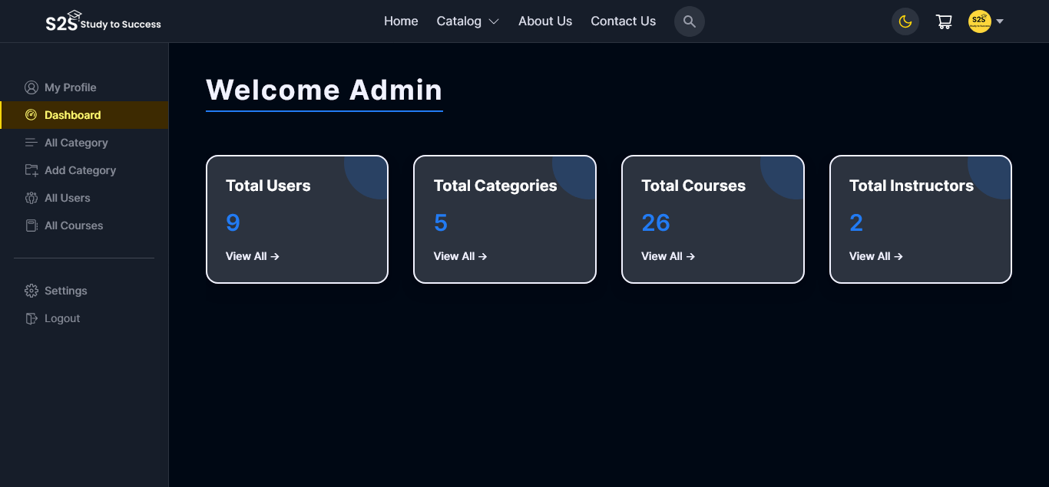

**5.31 Screenshots of All Category (Admin) Page**

Light Mode: Dark Mode: -

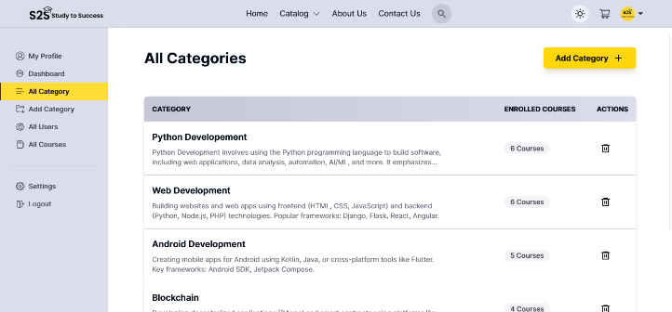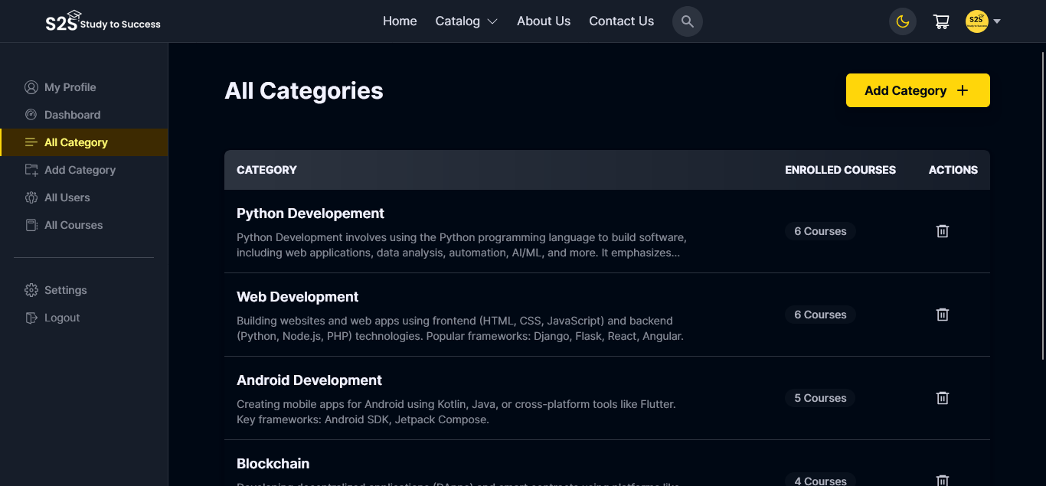

**5.32 Screenshots of Add Category (Admin) Page**

Light Mode: Dark Mode: -

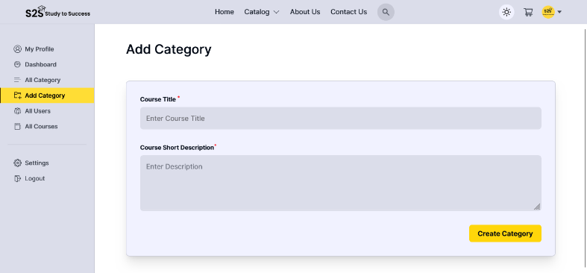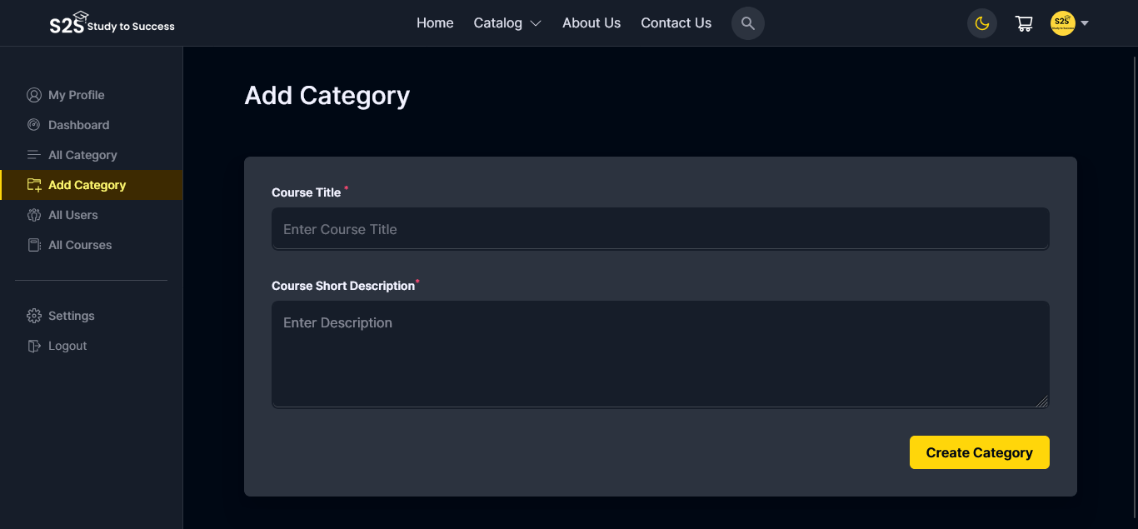

**5.33 Screenshots of All Users (Admin) Page**

Light Mode: Dark Mode: -

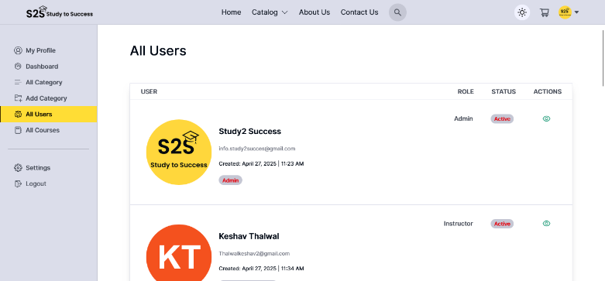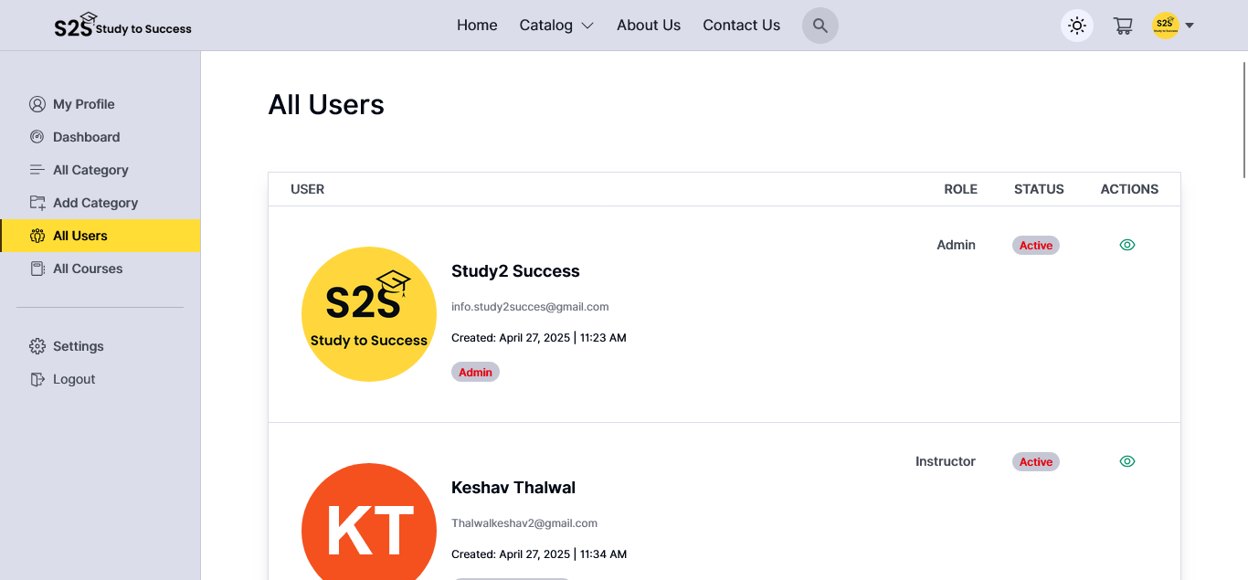

**5.34 Screenshots of All Courses (Admin) Page**

Light Mode: Dark Mode: -

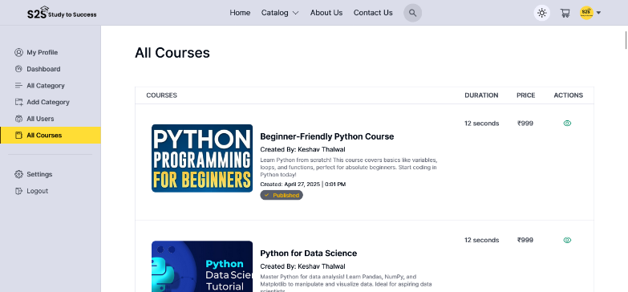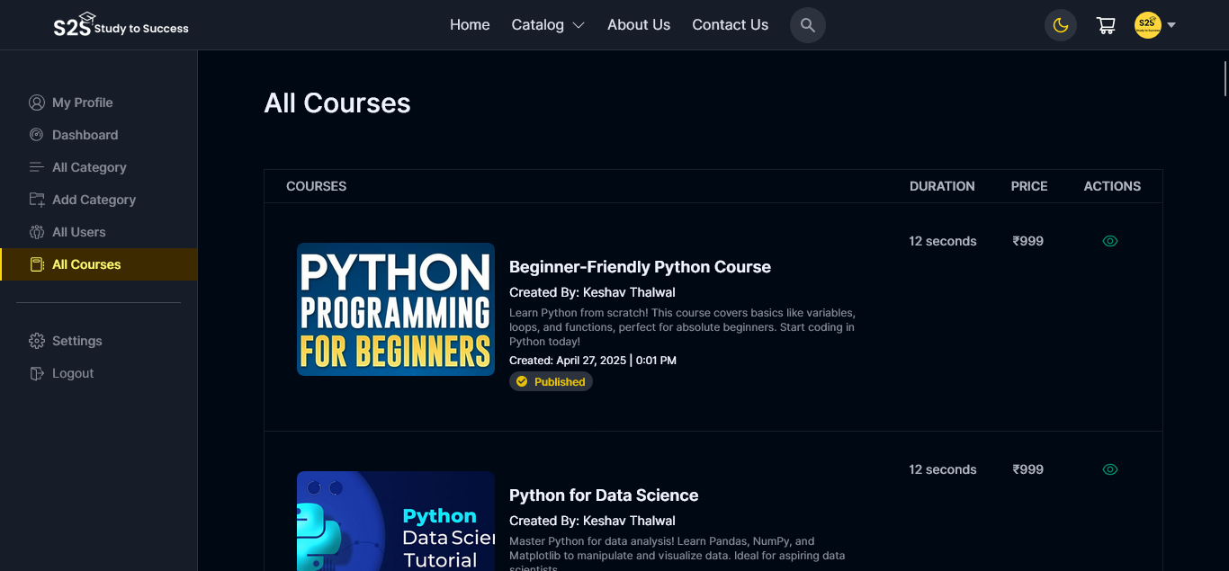

**5.35 Screenshots of Games (Student) Page**

Light Mode: Dark Mode: -

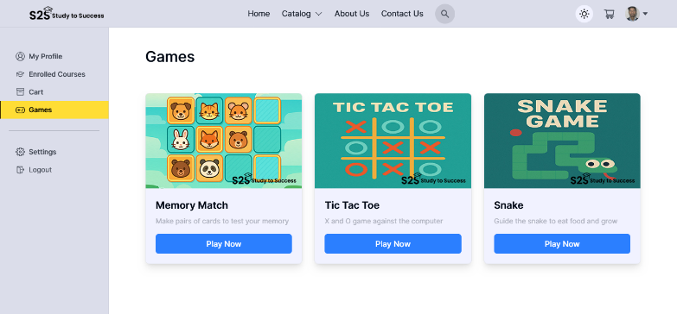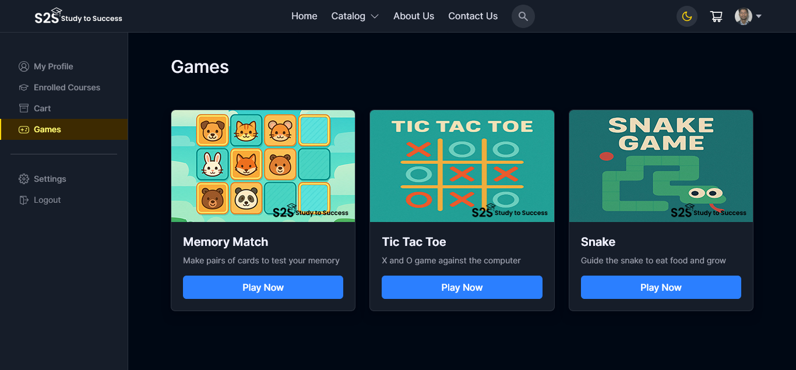

**SYSTEM TESTING**

**6.1 TESTING**

The purpose of testing is to discover errors. Testing is the process of trying to discover every conceivable fault or weakness in a work product. It provides a way to check the functionality of components, sub-assemblies, assemblies and/or a finished product It is the process of exercising software with the intent of ensuring that the Software system meets its requirements and user expectations and does not fail in an unacceptable manner. There are various types of tests. Each test type addresses a specific testing requirement.

**TYPES OF TESTING UNIT TESTING**

1. **UNIT TESTING**

Unit testing involves the design of test cases that validate that the internal program logic is functioning properly, and that program inputs produce valid outputs. It is the testing of individual software units of the application. It is done after the completion of an individual unit before integration. This is a structural testing, that relies on knowledge of its construction and is invasive. Unit tests perform basic tests at component level and test a specific business process, application, and/or system configuration.

1. **INTEGRATION TESTING**

Integration tests are designed to test integrated software components to determine if they actually run as one program. Testing is event driven and is more concerned with the basic outcome of screens or fields. Integration tests demonstrate that although the components were individually satisfaction, as shown by successfully unit testing. the combination of components is correct and consistent. Integration testing is specifically aimed at exposing the problems that arise from the combination of components.

1. **FUNCTIONAL TESTING**

Functional tests provide systematic demonstrations that functions tested are available as specified by the business and technical 29 requirements, system documentation, and user manuals, Functional testing is centered on the following items:

1. **SYSTEM TESTING**

System testing ensures that the entire integrated software system. It tests a configuration to ensure known and predictable results. System testing is based on the process descriptions, flows, emphasizing pre-driven process links and integration points.

**TEST RESULTS**

All the test cases mentioned above have passed successfully. No defects encountered.

**CONCLUSION AND FUTURE SCOPE**

**7.1 Conclusion**

Study2Success is a comprehensive **EdTech** **platform** designed to bridge the gap between quality education and learners by offering **structured**, **interactive**, and **affordable** courses. Leveraging the **MERN stack (MongoDB, Express.js, React.js, Node.js),** the platform ensures a **scalable**, **secure**, and **user-friendly** learning experience.

Key achievements of Study2Success include:

* **Personalized Learning**: Adaptive learning paths cater to different skill levels (beginner to advanced).
* **Engaging Content**: Interactive videos, downloadable notes, quizzes, and coding exercises enhance retention.
* **Monetization for Instructors**: Educators can create and sell courses, reaching a global audience.
* **Community & Peer Learning**: Discussion forums and review systems foster collaboration.
* **Secure & Scalable Architecture**: Robust authentication (JWT, OAuth), payment integration (Razorpay), and cloud hosting ensure reliability.

The platform successfully addresses common e-learning challenges, such as **lack of structured content, high costs, and passive learning methods**, making education more **accessible, engaging, and effective.**

**7.2 FUTURE SCOPE:**

Study2Success has significant potential for expansion and enhancement:

**1. AI-Powered Learning Enhancements**

* **Personalized Recommendations:** AI-driven course suggestions based on user progress and preferences.
* **Automated Assessments:** AI-based grading for coding exercises and quizzes.
* **Chatbot Support:** AI tutor for instant doubt resolution.

**2. Advanced Features for Learners & Instructors**

* **Live Coding Environments:** Real-time compiler integration for hands-on practice.
* **Offline Mode:** Downloadable content for learning without internet access.

**3. Expansion of Course Offerings**

* **Corporate Training:** Skill-based courses for professionals (e.g., DevOps, Cloud Computing).
* **K-12 & Competitive Exams:** School curriculum and test prep (JEE, NEET, UPSC).
* **Multilingual Support:** Courses in regional languages to reach wider audiences.

**4. Enhanced Collaboration Tools**

* **Peer Programming:** Live pair-coding sessions.
* **Mentorship Programs:** One-on-one guidance from industry experts.

**5. Mobile App Development**

* **Dedicated iOS & Android Apps:** Improved accessibility and push notifications.

**6. Blockchain for Certification**

* **Tamper-proof Digital Certificates:** Blockchain-verified credentials to enhance credibility.

**7. Global Expansion**

* **Partnerships with Universities & Companies:** Accredited courses and job placements.
* **Localized Pricing Models:** Subscription plans tailored to different regions.

**BIBLOGRAPHY**

For successfully complete my project file. I have taken help from the following**:**

**Website & Documentation: -**

1. **React Official Documentation.**
   * https://react.dev/learn
2. **Node.js Documentation.**
   * https://nodejs.org/docs/latest/api/
3. **MDN Web Docs. JavaScript Guide.**
   * https://developer.morzilla.org/en-US/docs/Web/JavaScript
4. **Tailwind CSS Documentation.**
   * <https://tailwindcss.com/docs>
5. **Express.js Official Guide**.
   * <https://expressjs.com/>
6. **Json Web Token JWT Documentation.**
   * https://jwt.io/introduction
7. **Cloudinary Image Upload Guide.**
   * <https://tailwindcss.com/docs>
8. **Axios GitHub Repository.**
   * <https://github.com/>axios/axios
9. **Redux Official Documentation.**
   * <https://redux.js.org>
10. **Bcrypt NPM Documentation.**
    * https://www.npmjs.com/package/bcrypt
11. **Razorpay Api Documentation.**
    * https://razorpay.com/docs/api/

**PEOPLE:**

* **Dr. Pradeep Pokhriyal**, Head of Department IT & CS.
* **Mrs. Manorama Uniyal,** Assistant Professor & Project Guides.
* **Ayush Kukreti** as **Co-Frontend Developer, Keshav Thalwal** as **Backend Developer, Abhay Sharma** as **Designer of Logo and Frontend** & All the faculty members of CS & IT department.